**Project Report**

**on**

**Online Cake Bakery System**

**ABSTRACT**

The online Cake Bakery System provides convenience for the customers. It overcomes the disadvantages of the traditional queuing system. This system increases the takeaway of cakes than visitors. Therefore, this system enhances the speed and standardization of taking the order from the customer. It provides a better communication platform. the user’s details are noted electronically.

The online Cake Bakery System set up menu online and the customers easily places the order with a simple mouse click. Also with a cake menu online you can easily track the orders, maintain customer's database and improve your cake delivery service. This system allows the user to select the desired cake from the displayed menu. The user orders the cakes. The payment can be made online or pay-on-delivery system. The user’s details are maintained confidential because it maintains a separate account for each user. An id and password is provided for each user. Therefore it provides a more secured Bakery.

**Introduction**

An online Cake Bakery System is a web-based application that stimulates the customers to put cake orders through internet. This application is based on the Open Source platform .

**OBJECTIVE:-**

The main objective of this project is to develop an application which gives provision to the bakery owners to flourish their business by uploading menus at no cost and will invariably lead to higher customer retention and acquisition rates.

**Existing System**

In existing system for giving any orders users should visit bakery to know about cake items and them give order and pay advance.  In this method time and manual work is required. Maintaining critical information in the files and manuals is full of risk and a tedious process.

**Proposed System:**

This online application enables the end users to register online, select the cake from the e-menu card, read the E-menu card and order cake online. By just selecting the cake that the user want to have. The results after selecting the cake from the E-menu card will directly appear in the screen of the bakery admin. By using this application the work of the men’s is reduced and we can also say that the work is nullified. The benefit of this is that if there is rush in the bakery then there will be chances that the waiters will be unavailable and the users can directly order the cake to the chef online by using this application. The user will be given a username and a password to login.

**Modules:**

Administrator module

Customer Module

**Administrator module**

Admin can view all the information about the user edit the all details about the customer.

* Create cake category
* Manage cake categories
* Add cake item
* Manage Cake item
* Manage user order
* View Enquiry
* View Subscriber Emails

**Customer Module**

This Functionality provided:

* View product’s list
* Register
* Place orders

**Admin Module**

1. Dashboard: In this section admin can see all detail in brief like total order, not confirmed order, confirmed order, Total cake being prepared, Total cake pickup, Total cake deliver, Total Cancelled orders, and Total user.
2. Reg Users: In this section admin can manage register user (view/update).
3. Cake Category: In this section admin can manage cake category (Add and Update).
4. Cake Menu: In this section admin can manage cake menu (Add and Update).
5. Orders: In this section admin can view the cake order details and they have also right to change order status according to current status.
6. Search Order: In this section admin can search particular order with the help of order number.
7. Reports: In this section admin can view order details, order counts and sales report according to dates.
8. Pages: In this section admin can updates about us and contact us page.
9. Enquiry: In this section admin can view the enquiry which is sent by users.
10. Subscriber: In this section admin view subscriber mails.

Admin can also update his profile, change password and recover password.

**User Module**

1.Cake Menu: In this section user can view which cake available in bakery

2. My Accounts: In this section user can his/her password , view and update his/her profile and logout from accounts.

3.My orders: In this section user can view order history after login.

4. Cart: In this section user can add their cake which he/her want to order.

5. User has also a facility to download his/her invoice and cancel order if he/her wants to cancel.

**Brief Information about homepage**

In this page guest user (user which not registered) can view bakery cake menu, search cake according cake name and guest user can also sign up in bakery and registered user can sign in. User can also track their order without login.

**HARDWARE AND SOFTWARE REQUIREMENTS**

### Hardware Requirement:

* Hardware - Pentium
* Speed - 1.1 GHz
* RAM - 1GB
* Hard Disk - 20 GB
* Key Board - Standard Windows Keyboard
* Mouse - Two or Three Button Mouse
* Monitor - SVGA

### Software Requirements:

* Operating System : Windows / Linux / Mac
* Technology : PHP
* Web Technologies : Html, JavaScript, CSS
* IDE : Notepad++
* Web Server : WAMP / XAMPP / LAMP / MAMP (any one)
* Database : My SQL

**Design**

**INTRODUCTION:**

Design is the first step in the development phase for any techniques and principles for the purpose of defining a device, a process or system in sufficient detail to permit its physical realization.

Once the software requirements have been analyzed and specified the software design involves three technical activities - design, coding, implementation and testing that are required to build and verify the software.

The design activities are of main importance in this phase, because in this activity, decisions ultimately affecting the success of the software implementation and its ease of maintenance are made. These decisions have the final bearing upon reliability and maintainability of the system. Design is the only way to accurately translate the customer’s requirements into finished software or a system.

Design is the place where quality is fostered in development. Software design is a process through which requirements are translated into a representation of software. Software design is conducted in two steps. Preliminary design is concerned with the transformation of requirements into data.

UML Diagrams:

Actor:  
A coherent set of roles that users of use cases play when interacting with the use `cases.

Use case:

A description of sequence of actions, including variants, that a system performs that yields an observable result of value of an actor.



UML stands for Unified Modeling Language. UML is a language for specifying, visualizing and documenting the system. This is the step while developing any product after analysis. The goal from this is to produce a model of the entities involved in the project which later need to be built. The representation of the entities that are to be used in the product being developed need to be designed.

There are various kinds of methods in software design:

They are as follows:

* Use case Diagram
* Sequence Diagram
* Collaboration Diagram
* Activity Diagram
* State chat Diagram

**USECASE DIAGRAMS:**

Use case diagrams model behavior within a system and helps the developers understand of what the user require. The stick man represents what’s called an actor.

Use case diagram can be useful for getting an overall view of the system and clarifying who can do and more importantly what they can’t do.

Use case diagram consists of use cases and actors and shows the interaction between the use case and actors.

* The purpose is to show the interactions between the use case and actor.
* To represent the system requirements from user’s perspective.
* An actor could be the end-user of the system or an external system.

**USECASE DIAGRAM:**

A Use case is a description of set of sequence of actions. Graphically it is rendered as an ellipse with solid line including only its name. Use case diagram is a behavioral diagram that shows a set of use cases and actors and their relationship. It is an association between the use cases and actors. An actor represents a real-world object. Primary Actor – Sender, Secondary Actor Receiver.

**Admin Use Case Diagram :**

**Admin**

**User Use Case Diagram :**

**User**

**E-R Diagrams:**

The Entity-Relationship (ER) model was originally proposed by Peter in 1976 [Chen76] as a way to unify the network and relational database views. Simply stated the ER model is a conceptual data model that views the real world as entities and relationships. A basic component of the model is the Entity-Relationship diagram which is used to visually represents data objects. Since Chen wrote his paper the model has been extended and today it is commonly used for database design For the database designer, the utility of the ER model is:

* it maps well to the relational model. The constructs used in the ER model can easily be transformed into relational tables.
* it is simple and easy to understand with a minimum of training. Therefore, the model can be used by the database designer to communicate the design to the end user.
* In addition, the model can be used as a design plan by the database developer to implement a data model in a specific database management software.

## Connectivity and Cardinality

The basic types of connectivity for relations are: one-to-one, one-to-many, and many-to-many. A *one-to-one* (1:1) relationship is when at most one instance of a entity A is associated with one instance of entity B. For example, "employees in the company are each assigned their own office. For each employee there exists a unique office and for each office there exists a unique employee.

A *one-to-many* (1:N) relationships is when for one instance of entity A, there are zero, one, or many instances of entity B, but for one instance of entity B, there is only one instance of entity A. An example of a 1:N relationships is

a department has many employees each employee is assigned to one department

A *many-to-many* (M:N) relationship, sometimes called non-specific, is when for one instance of entity A, there are zero, one, or many instances of entity B and for one instance of entity B there are zero, one, or many instances of entity A. The connectivity of a relationship describes the mapping of associated

## ER Notation

There is no standard for representing data objects in ER diagrams. Each modeling methodology uses its own notation. The original notation used by Chen is widely used in academics texts and journals but rarely seen in either CASE tools or publications by non-academics. Today, there are a number of notations used, among the more common are Bachman, crow's foot, and IDEFIX.

All notational styles represent entities as rectangular boxes and relationships as lines connecting boxes. Each style uses a special set of symbols to represent the cardinality of a connection. The notation used in this document is from Martin. The symbols used for the basic ER constructs are:

* **Entities** are represented by labeled rectangles. The label is the name of the entity. Entity names should be singular nouns.
* **Relationships** are represented by a solid line connecting two entities. The name of the relationship is written above the line. Relationship names should be verbs
* **Attributes**, when included, are listed inside the entity rectangle. Attributes which are identifiers are underlined. Attribute names should be singular nouns.
* **Cardinality** of many is represented by a line ending in a crow's foot. If the crow's foot is omitted, the cardinality is one.
* **Existence** is represented by placing a circle or a perpendicular bar on the line. Mandatory existence is shown by the bar (looks like a 1) next to the entity for an instance is required. Optional existence is shown by placing a circle next to the entity that is optional

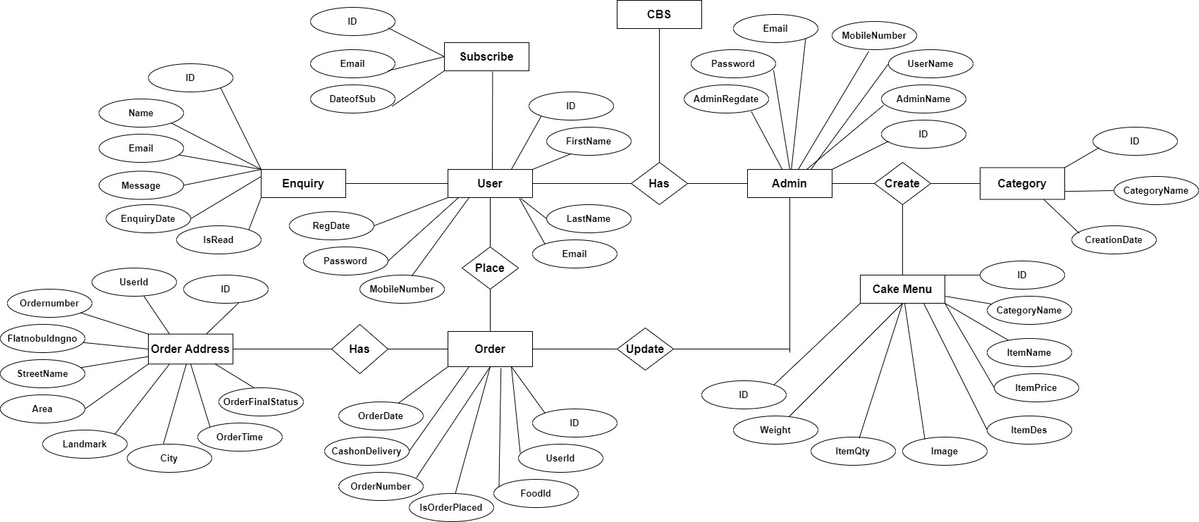

**Database Design**

The data in the system has to be stored and retrieved from database. Designing the database is part of system design. Data elements and data structures to be stored have been identified at analysis stage. They are structured and put together to design the data storage and retrieval system.

A database is a collection of interrelated data stored with minimum redundancy to serve many users quickly and efficiently. The general objective is to make database access easy, quick, inexpensive and flexible for the user. Relationships are established between the data items and unnecessary data items are removed. Normalization is done to get an internal consistency of data and to have minimum redundancy and maximum stability. This ensures minimizing data storage required, minimizing chances of data inconsistencies and optimizing for updates. The MS Access database has been chosen for developing the relevant databases.

**Cake Bakery System (CBS) contains 10 MySQL tables:**

**tbladmin :** This table store the admin login details

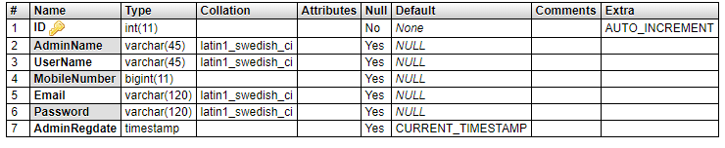

**tblcategory :** This table stores the cake category

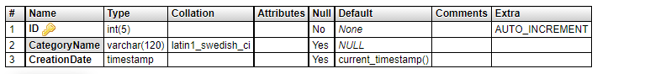

**tblcontact:** This table stores enquiry detail of users.

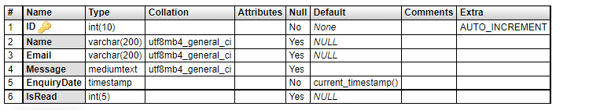

**tblfood :** This tables stores the cake details (used for cake menu)

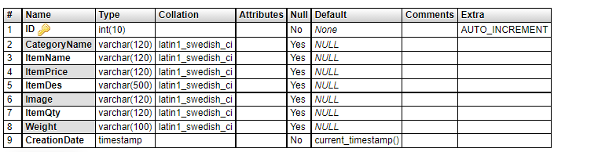

**tblfoodtracking :** This table stores the cake tacking data.

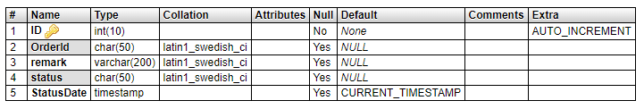

**tblorderaddresses :** This table stores the delivery address.

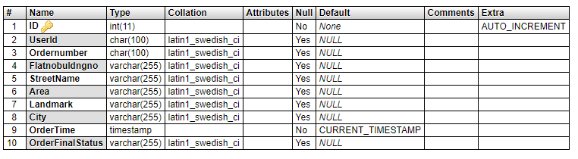

**tblorders:** This table store the cake order details.

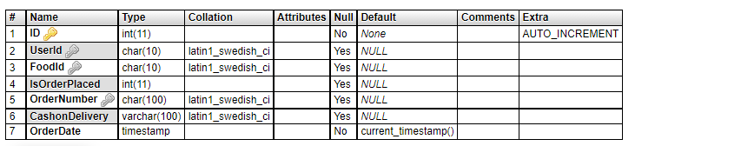

**tblpage:** This table store the details of contact us and about us page.

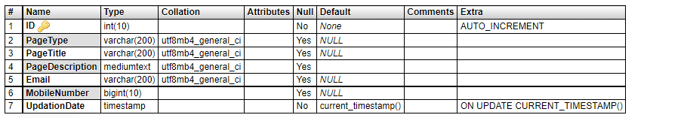

**tbluser :** This table store the user details.

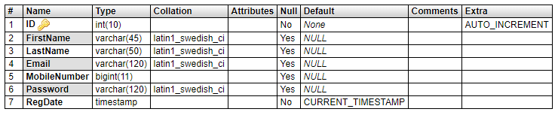

**tblsubcriber:** This table store the subscriber emails.

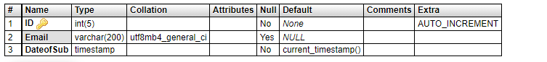

**Tables Relationship Diagram**

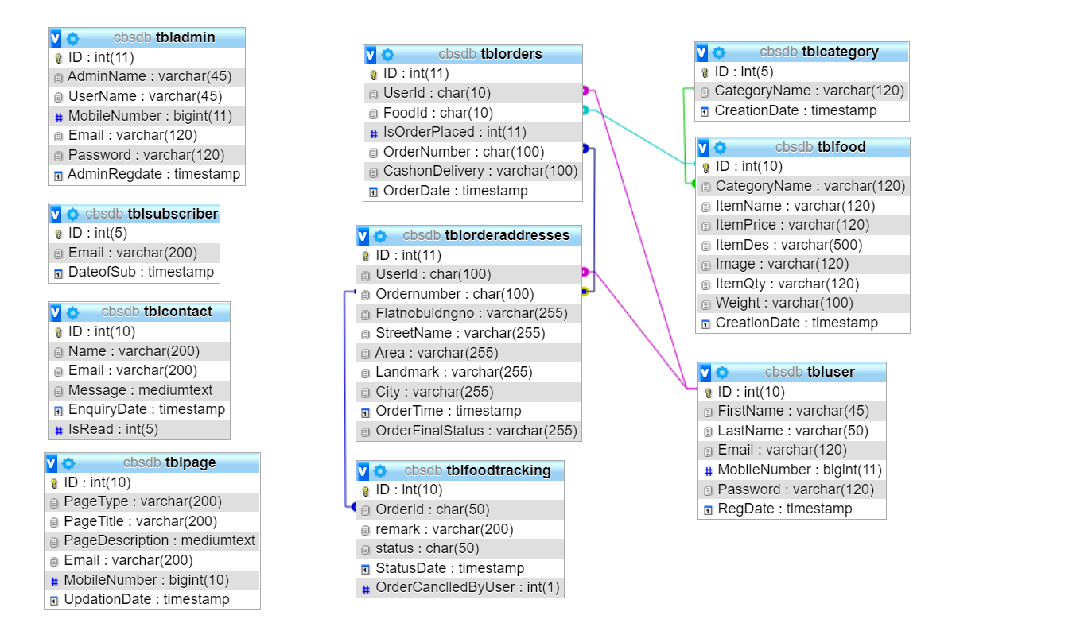

**SYSTEM TESTING**

**Project Implementation & Testing**

At the end of the system design, it is the beginning for the actual coding to develop the proposed system. During development phase, the table structure of the database will be first built in order to provide a suitable data types that suit the system back end development, system connection and data transfer. Next, the computer side client program will be developed and follow by will be the web services that allow mobile phone client program to communicate with the server and lastly mobile phone side client program will be developed. In testing phase, several test cases will be carrying out to test the system in order to determine the system reliability and system accuracy. According to the test cases, a system testing report will be generated for further review to figure out the system weaknesses and made improvement accordingly. In the deployment phase, several training will be provided for the particular restaurant staff such as how to operate the system, the procedure of handling different event and several instruction that need to be follow when operating the system.

**Implementation Issues & Challenges**

During the system implementation phase, several challenges need to be confront because it involve end users to test the production system with various situation. The possible challenges may face are as following:

**User without background**

The users are required to have basic knowledge of how to operate a computer system and android mobile phone in order to use the system. This will be difficulty to give training to the user as the basic knowledge information can be obtained from internet easily.

**The screen size of different device**

This would be one of the issue that will encounter while implementing the system. Because user are able to download the mobile application from the official website and use it as a client device to place order. Therefore, if the user device screens size are too small or too big. The content and interface of the application may not consistence.

**Server performance**

During real time system implementation, three would be a huge number of client that access to the server at the same time. Therefore, it may slow down the connection and performances of the system and even causes the server down if the issue goes beyond the level of acceptance.

**Development Tools**

**Database Environment**

The proposed system will need a database system to support in order to store the huge amount of data. MySQL database system will be chosen to support the proposed system because it is well-known open source relational database management system. Other than that, MySQL database system provides software developer with a client program with easy understanding graphical user interface that can communicate to the MySQL database server named as MySQL Workbench 6.3 CE. By doing so, software developer can interact with the database system with the user friendliness client program and without using the command prompt, at the end it may speed up the development progress.

**Web Technology**

The proposed system is a cross platform system, which include Windows desktop client and Android mobile phone client. Therefore, it require to implement web services in order to support the Android mobile phone client device to fetch data from the database server and store data back to the database server. In this project, WampServer is used to support the issue that mention earlier. WampServer is a Windows web development environment that built-in comes together with the Apache, PHP and MySQL database. Furthermore, PHP will be the programming language that used to create the web services that store in the server and it is able to call by the Android mobile phone client to perform particular task.

**System Platform**

The project is a cross platform based system which includes Windows desktop client device and Android mobile phone client device in order to operate the proposed system

Therefore, IOS mobile phone client device will not compatible with the proposed system.

**Project Management Tool**

For the rule of thumb to develop a system, it requires to have an intact system planning which serve as a guide line during the development phases. Microsoft Project is a project management software program and it has been used in the project to design the system planning, project timeline, managing of resources, tracking development progress and etc.

**Visual Paradigm Community Edition**

In this project, Visual Paradigm software has been used to create document for several system planning diagram such as Use-Case diagram, Activity diagram, Class diagram and etc. By doing so, software developer are able to visualize the system communicate information much more concisely and clearly.

**Test Plan**

After the system has been developed, it will move to system testing phase. In system testing phase, the developed system is required to install on appropriate devices for testing purpose. After the system installation has been completed, the system testing task will be performed by different roles of user such as manager role and staff role. The purpose of system testing is to identify and determine the degree of system stability. At the same time, it is given an opportunity for developer to figure out error or bug that has not been raise and encounter during the system development phase. Those error or bug that has been found during the system testing activities will be solved before the system release. Each and every testing before system testing phases is actually tested by the system developer itself. Therefore, it might cause some biases toward the testing due to the system developer have knowledge about the system software logics and lead the result to be inappropriate. There are four types of testing that will be used to test the developed system which includes unit testing, integration testing, system testing and acceptance testing.

**Unit Testing**

First of all, unit testing will be the first testing method that used to test the developed system. It consists of testing activities that test the system module by module which has not been integrated as a whole. By doing unit testing, developer are able to identify error and bug easily since it is finding the error and bug through a unit part of the system rather than finding error through the complete system. In addition, developer will test the unit part of the system with the validation and the correctness of data value. Valid and invalid input will be entering to test and ensure the system processes perform with an expected result.

**Functional Testing**

After conducted the unit testing, functional testing will begin to test the developed system. Functional testing is performed to verify that the system application processes that perform and functioning appropriately according to the design specifications. In functional testing, the core system application functions will be tested with several test cases in order to ensure that the entire system functioning as a whole and perform task that with the expected results.

**Testing**

System testing of the software and hardware is a testing conducted on a system which is complete, integrated system that works as a whole. System testing is a critical testing procedure that must be conducted by software developer before the system released. During system testing it can evaluate the system’s compliance with its specified requirements according to the system design. Furthermore, several testing activities in system testing test not only the design of the system, but also the behavior and the believed expectations result from the customer. In addition, various complex test cases that used to test the system are according to the business process requirements which are collected from the user. Meanwhile, errors or bugs that detected during the testing is required software developer look into it from the initial step of the business process to the end of the process to ensure it have expected result in order to solve the errors or bugs to determine the degree of system stability.

**Acceptance Testing**

Last but not lease, acceptance testing also known as user acceptance testing would be the final testing procedure that perform to test the developed software system. In acceptance testing, the testing activities are different compare to the testing activities that mentioned previously because the tester that tests the system will be the final user which do not have knowledge about the system logic. If the final user encountered an error while using the system, system developer are required to maintain the system as soon as possible and release a new patch for the existing system to recover the error. Meanwhile, final user will use the system that visualized as to support their real business routine operation, therefore software support team are required to stand by to provide technical support while final user need any help or support that regarding the system. If there is no errors detected by the final user while using the system for a long period, the development job of developer is consider as complete and the system will be a final system product.

**SYSTEM EVALUATE AND DISCUSSION**

**Proposed System Completion**

The proposed system is designed and developed to solve all the problem statements which are stated in chapter one of this report. First of all, the developed system provides a feature that is able to solve the problem of difficulties in cake order ticket tracking and achieve the project objective of prevention of cake serves not in sequence. By using the system, it allow staff to placed order ticket through using the system and the system will automatically queue the cake order information according to the first come first serve basis and kitchen staff is able to follow the cake queue to serve customer accordingly. It also eliminates all the manual processes that involve in the traditional method of delivering cake order ticket. In addition, the developed system allows manager to update all the cake information as it is needed. This features helps restaurant to eliminate duplicated physical menu card which contain misleading information and also allow staff and customer to view the latest updated cake menu information through using the system. By doing so, it helps restaurant to solve the problem which regarding difficulties in updating menu card information, difficulties in providing appropriate updated cake information and the potential of increase cost of operation as the system will automatically refresh all the updated information that is edited by manager. Furthermore, the project objective which regarding provides convenience for both employees and consumers has been achieved because the system allow consumer to view all the updated information through the mobile phone client devices and it reduce the number of manual work which restaurant staff need to be performed. Last but not lease, the project objective of assisting restaurant to plan ahead has been achieved due to the system allow manager to generate several types of report in order to assist the restaurant to plan ahead. By analyzing the generated report, manager is able to carry out a planning for the next business routine of the restaurant in order to improve the restaurant operation efficiency. In a nutshell, the system has fulfilled all significant outcomes that according to all the problem statements and project objectives that are stated.

**System Strength and Limitation**

**System Strength**

The system provide customer with good dine in experience as it allow customer to view cake information and place order through using the mobile phone device. The mobile application also provides ease of use because it has easy understandable graphic user interface and minimal instruction to follow while place order through the application. Next, it helps restaurant staff to serve their value customer in minimal delay. Furthermore, the system can be implemented with low cost and is affordable for most of the small medium enterprise restaurant, because the hardware requirements are not required to be high end powerful in order to support the system. Lastly, server and client are communicating within the restaurant which is intranet therefore it does not need to have internet access.

**System Limitation**

The system is not compatible with IOS mobile devices as the mobile application is developed in Android environment. Therefore, for IOS mobile phone user may not able to install the application in their mobile phone and experience the system. Meanwhile, the restaurant has prepared some Android mobile devices which are used to resolve the issue that mention above. Next, due to the mobile phone client devices are required to connect to the wireless intranet in order to communicate with the server. It is very important to identify a suitable location that used to install and set up the wireless access point in order to ensure the wireless signal coverage is able to reach the entire restaurant area.

**Future Enhancement**

The system can implement a feature which is real time notification from the mobile phone application to the service desk. This feature enable customer to request customer service through using the mobile application rather than verbally call restaurant staff to approach them. In addition, the mobile application also can implement a feature that allow customer to update the cake serve status. For example, customers fine dining at the restaurant they can request the cake to be serve through using the mobile application and if the customer finish the main course and feeling full, the customer may request do not serve the following cake through using the mobile application. Last but not lease, the mobile application may implement some mini game that is able to entertain customers while they are waiting for the cake to be served.

**Project Output Screens**

**Home Page**

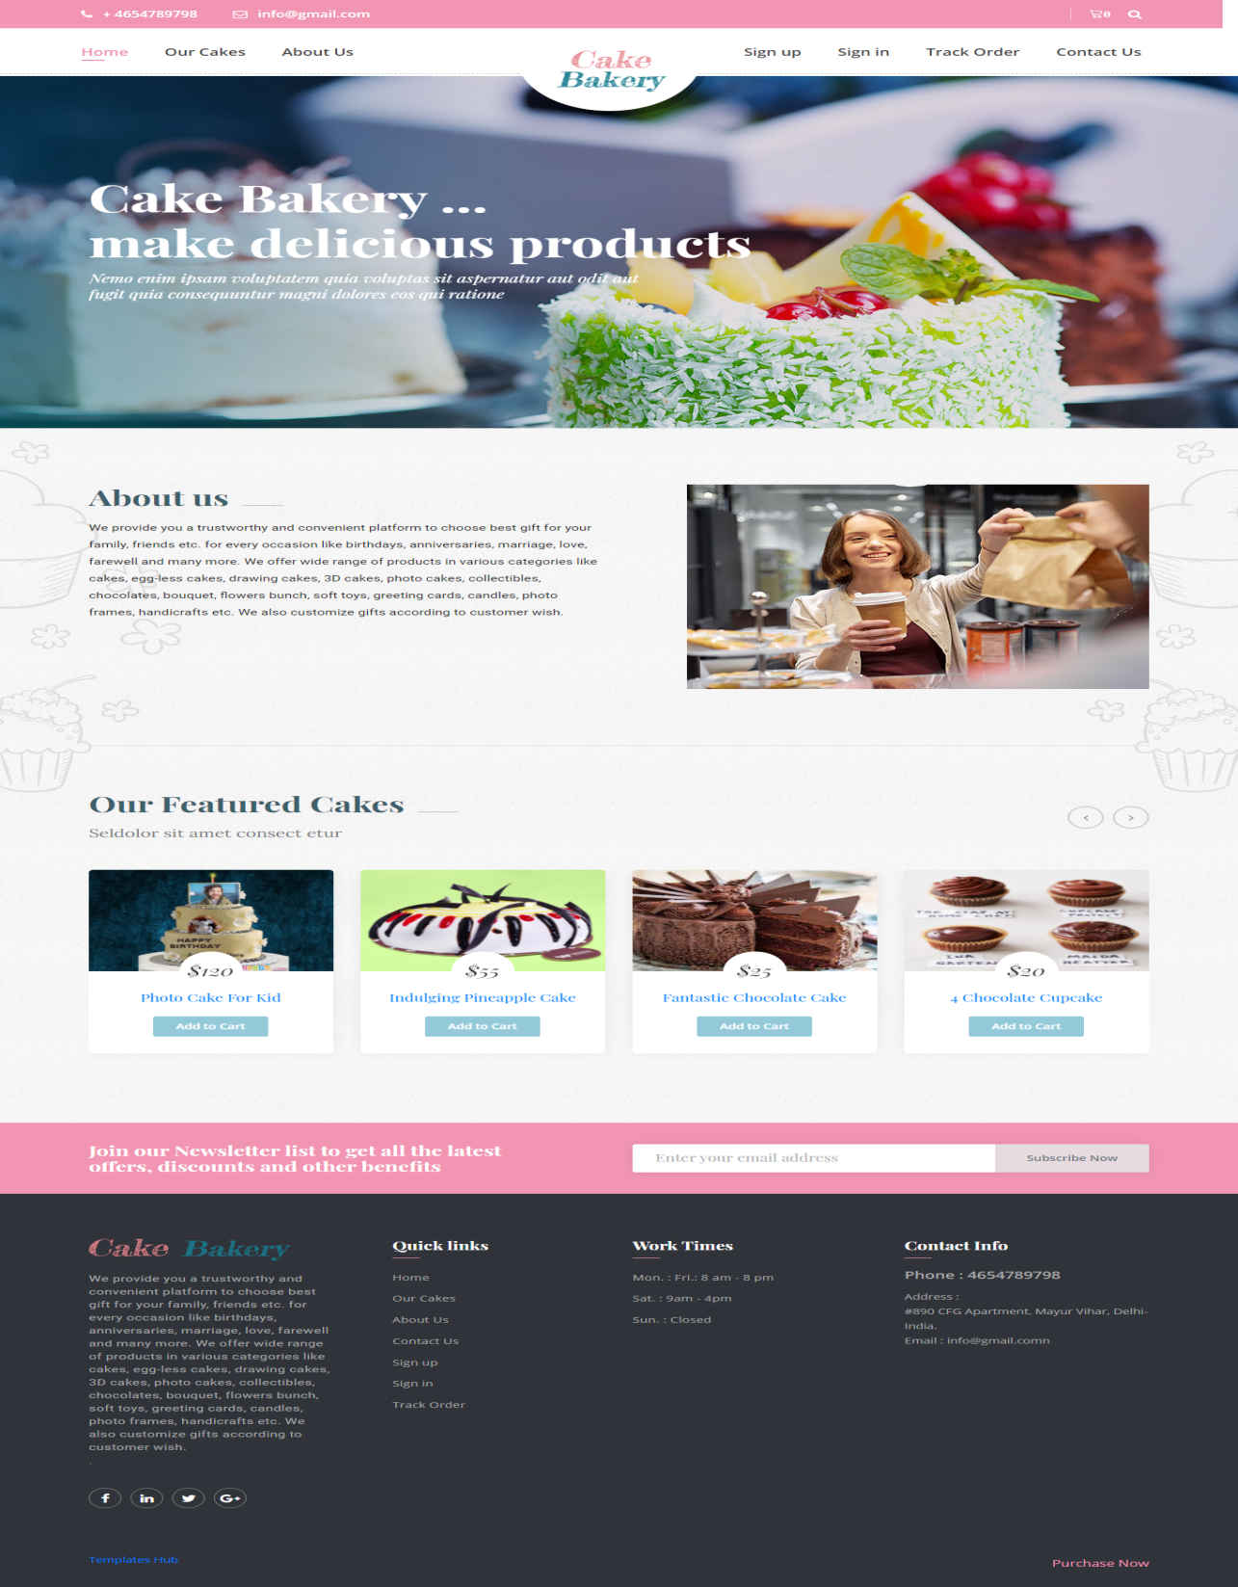

**Our Cakes**

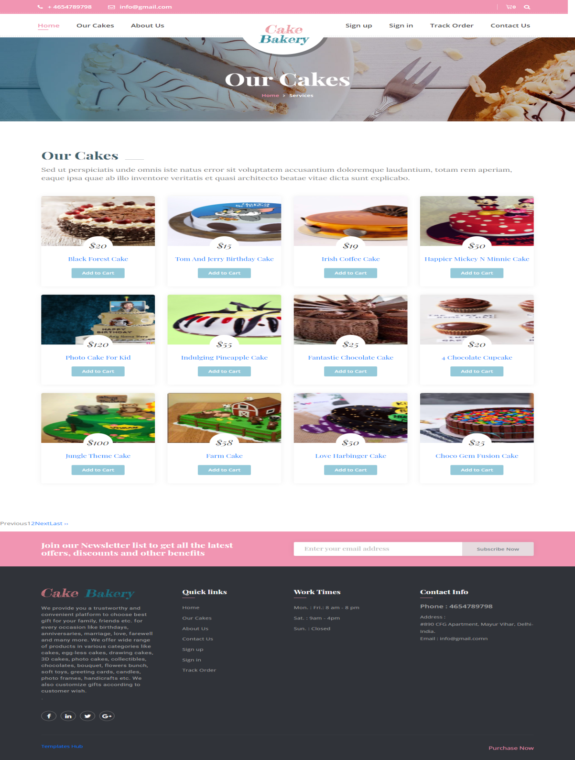

**Cake Details**

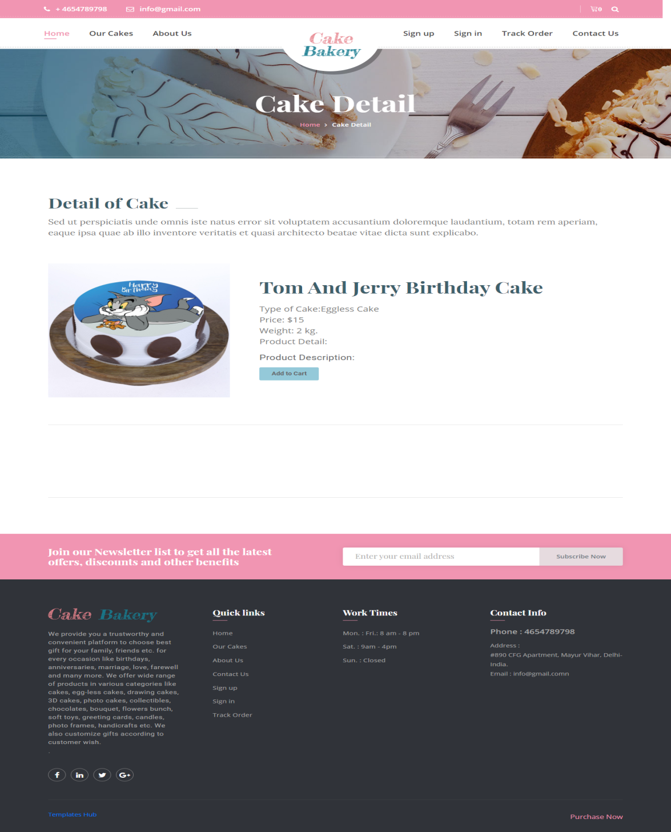

**About Us**

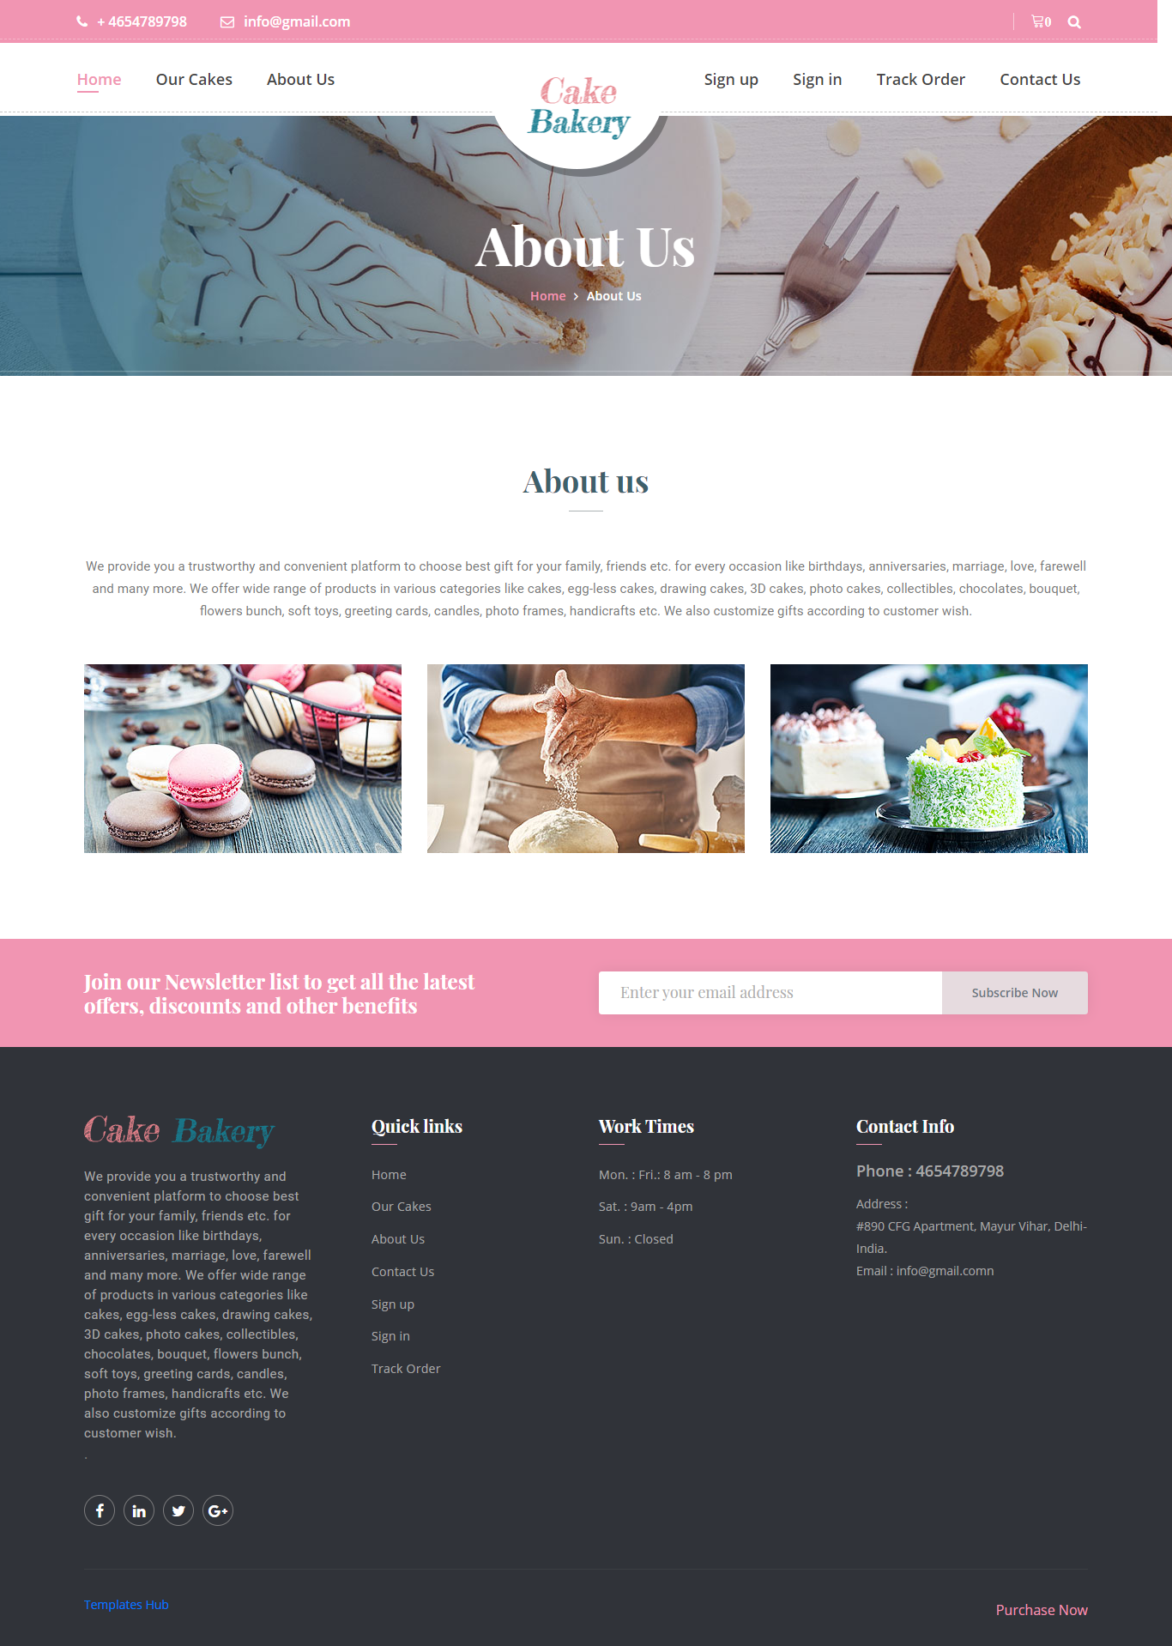

**Contact Us**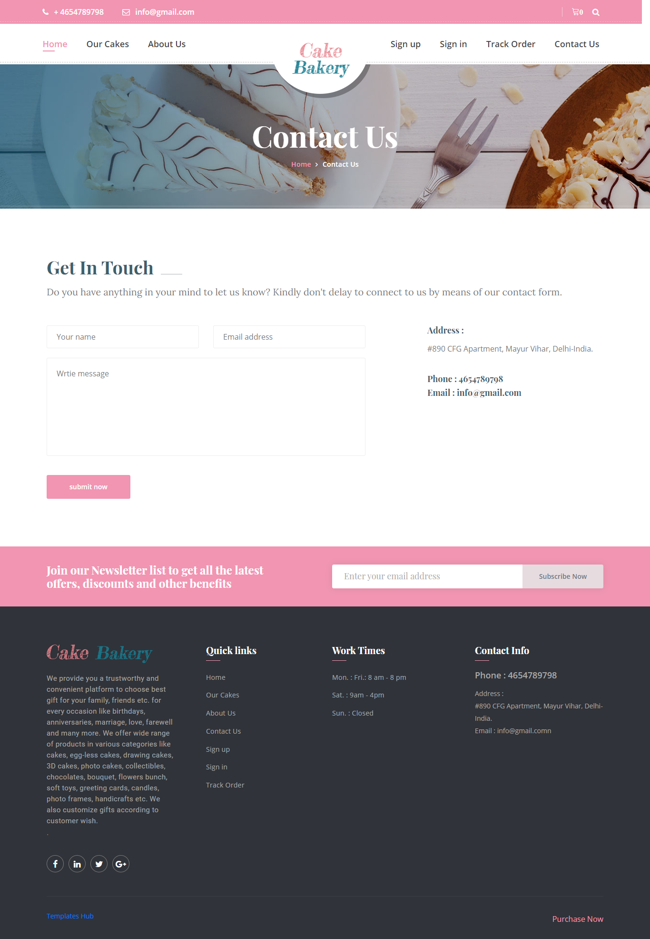

**Track Order**

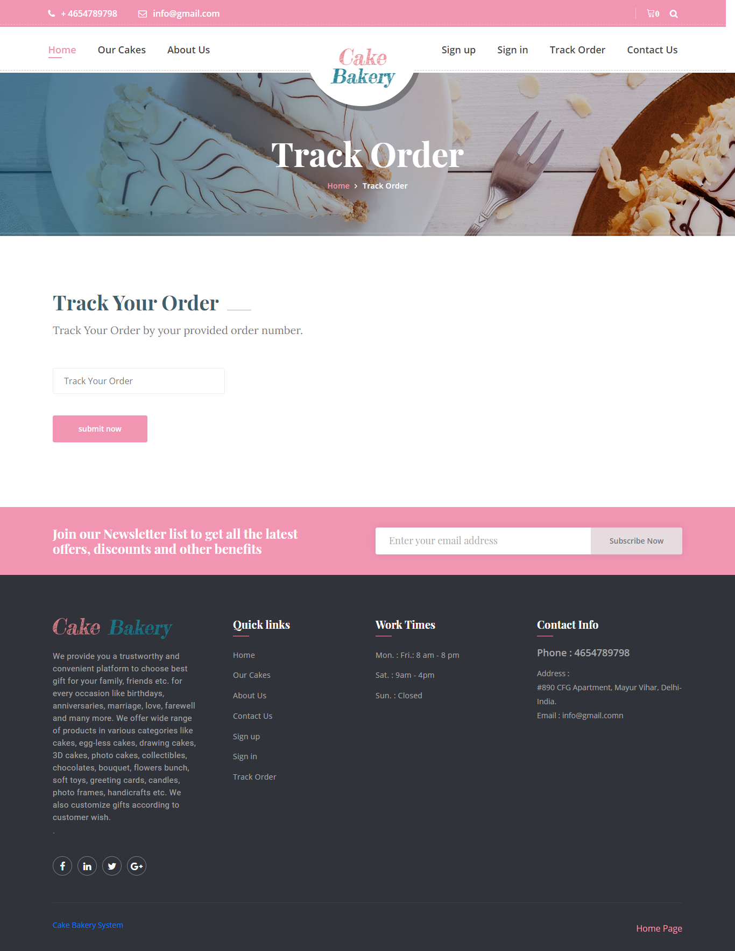

**User Sign Up**

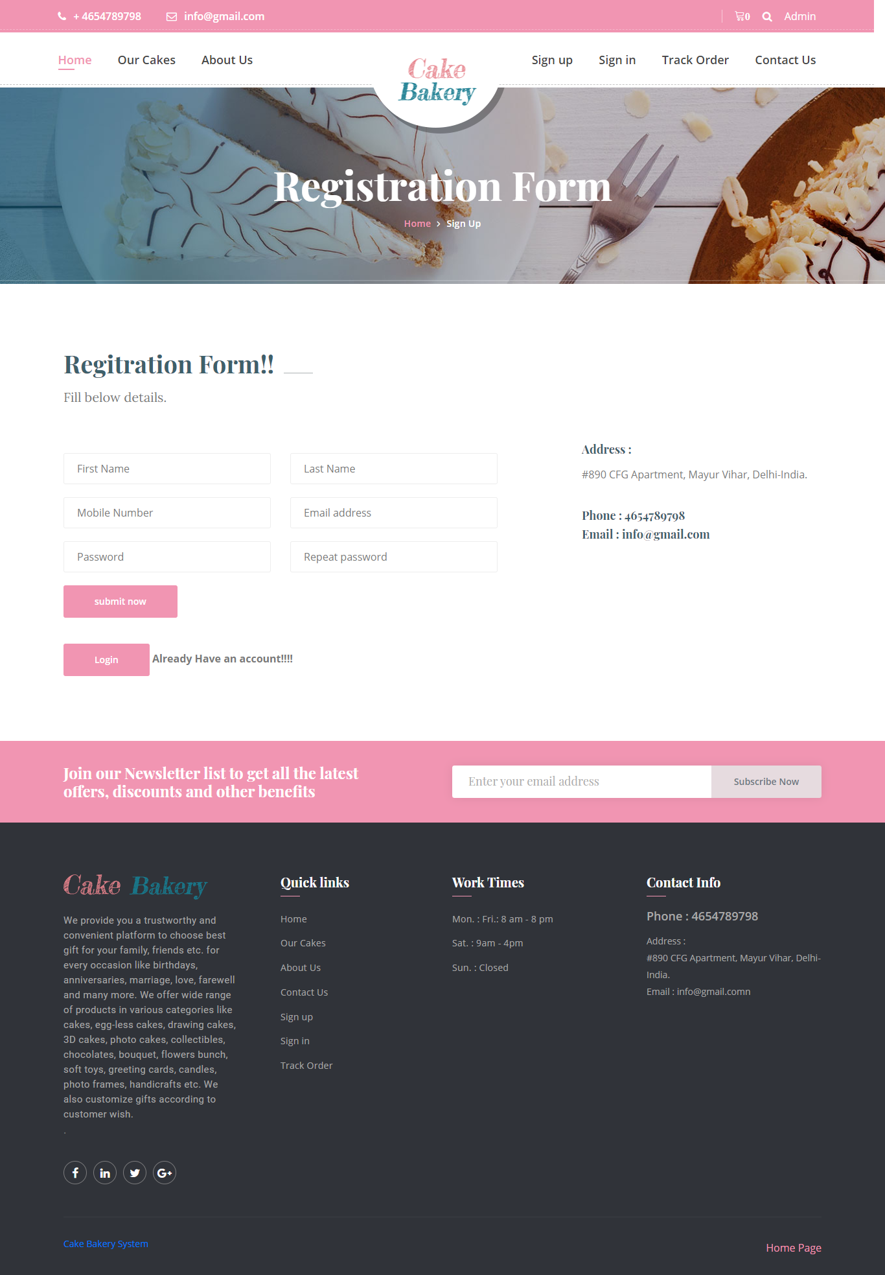

**User Sign in**

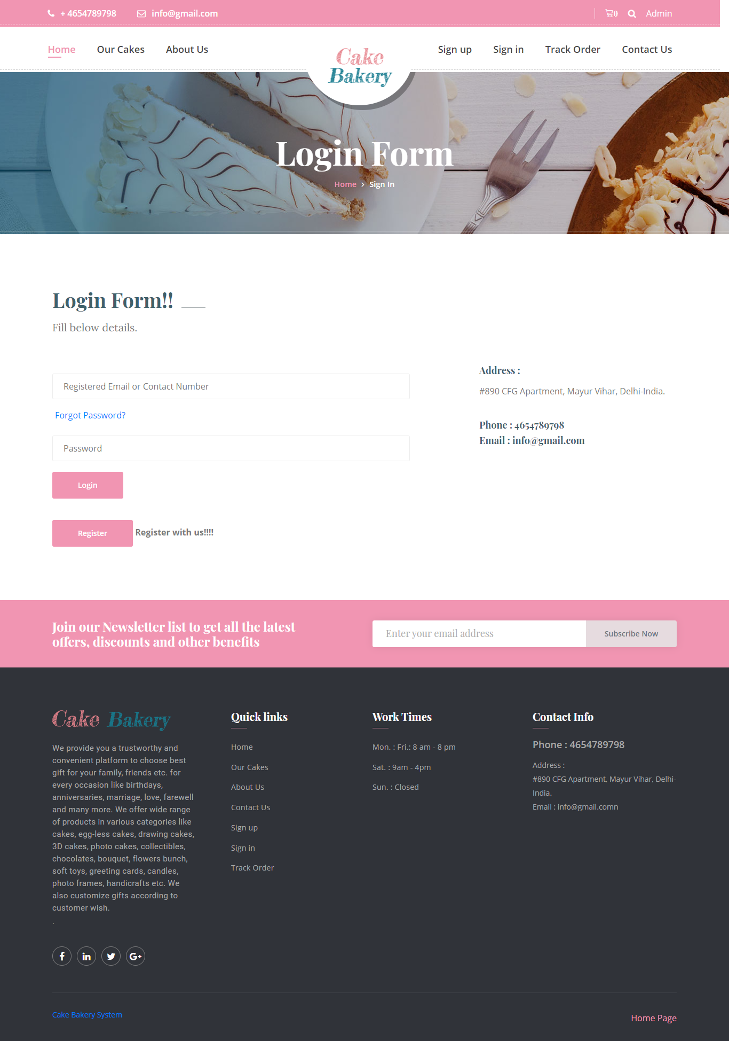

**Forgot Password**

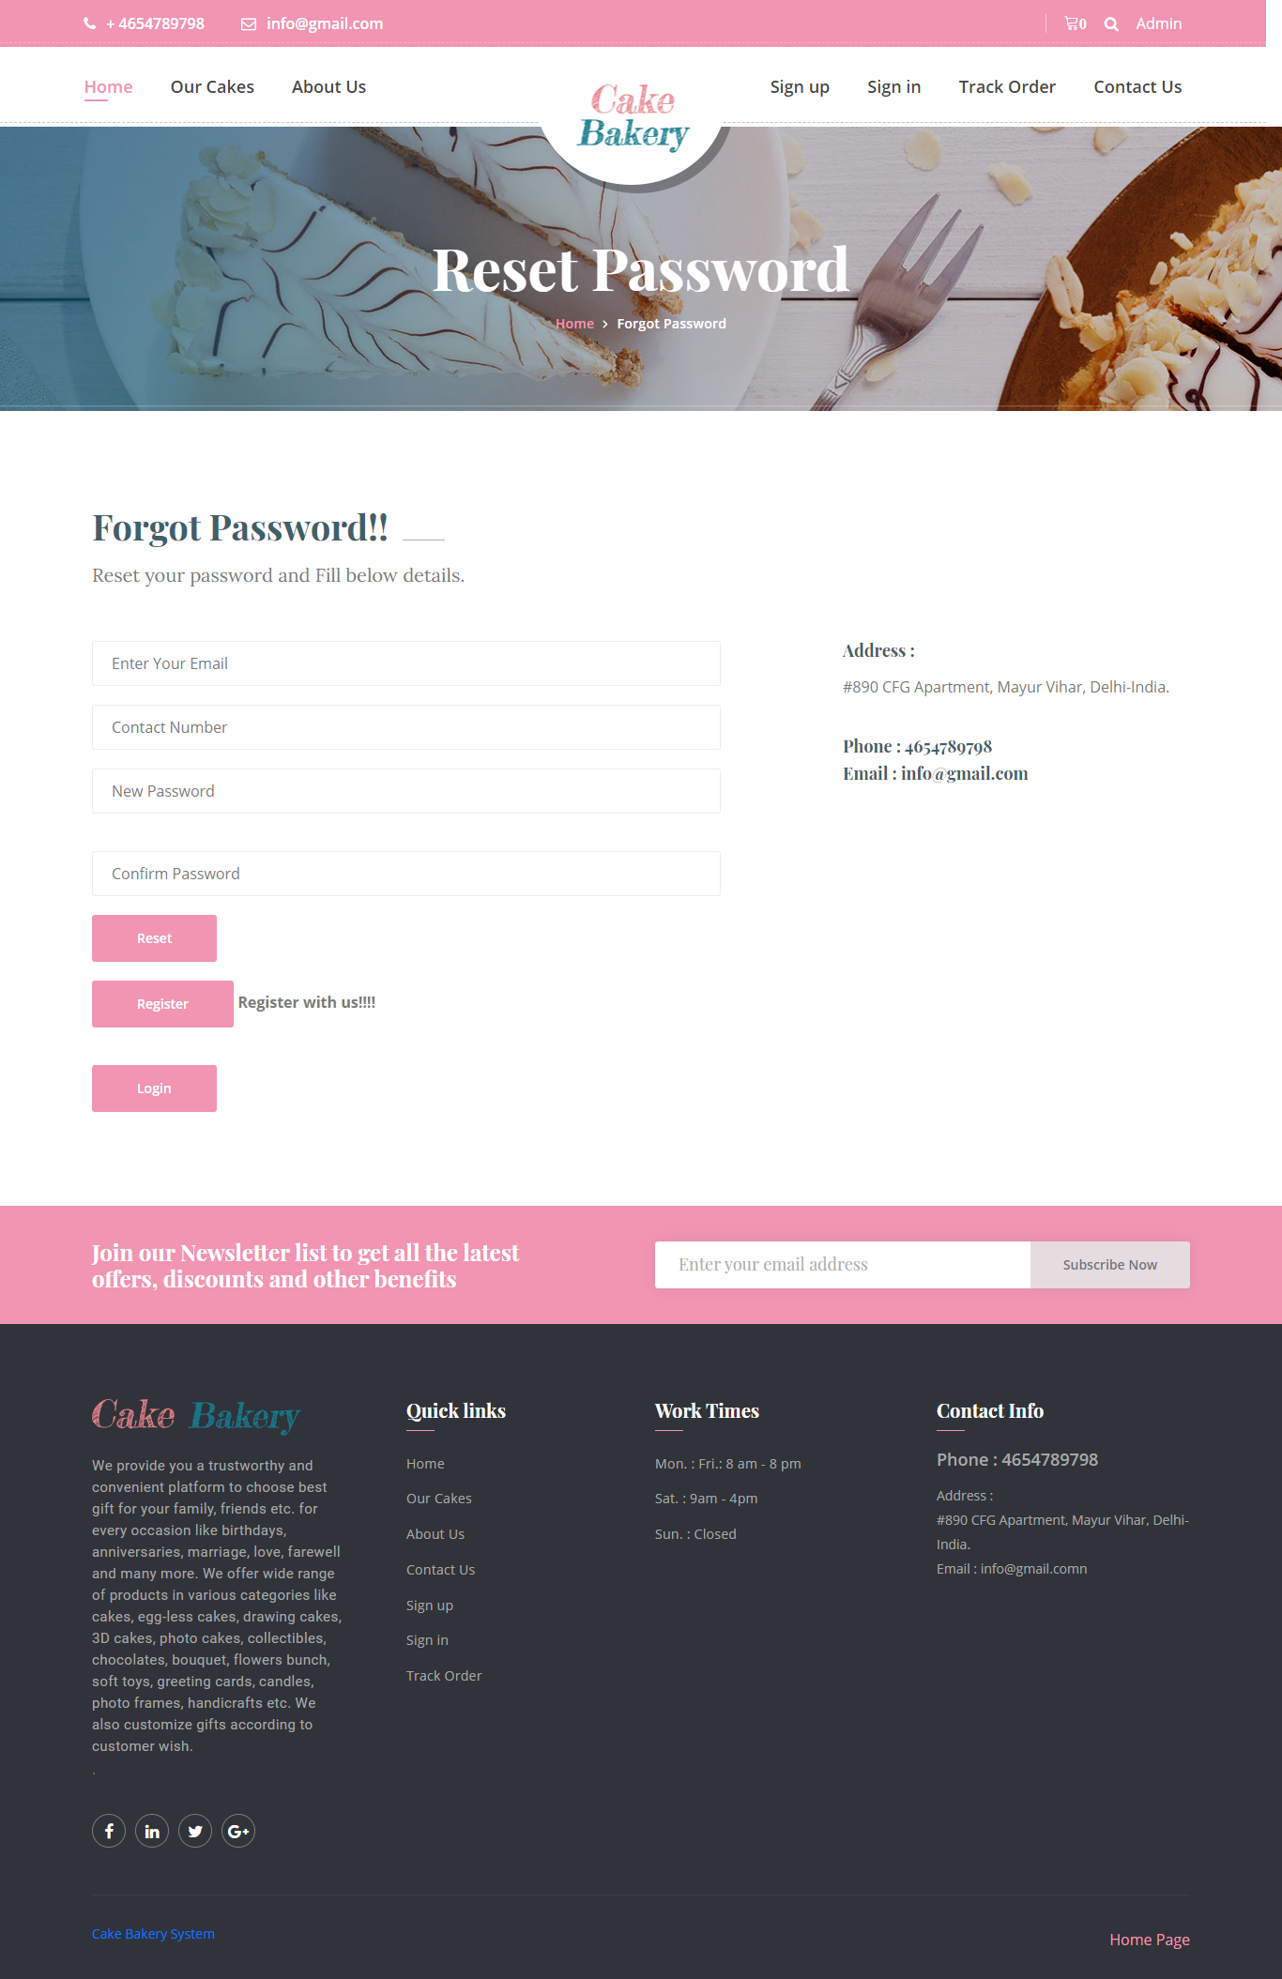

**User Profile**

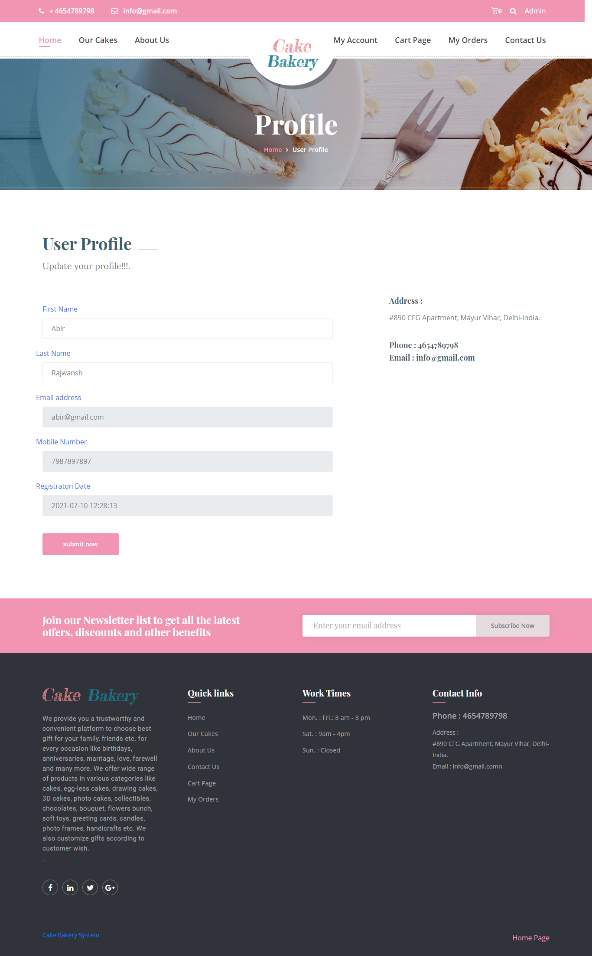

**Change Password**

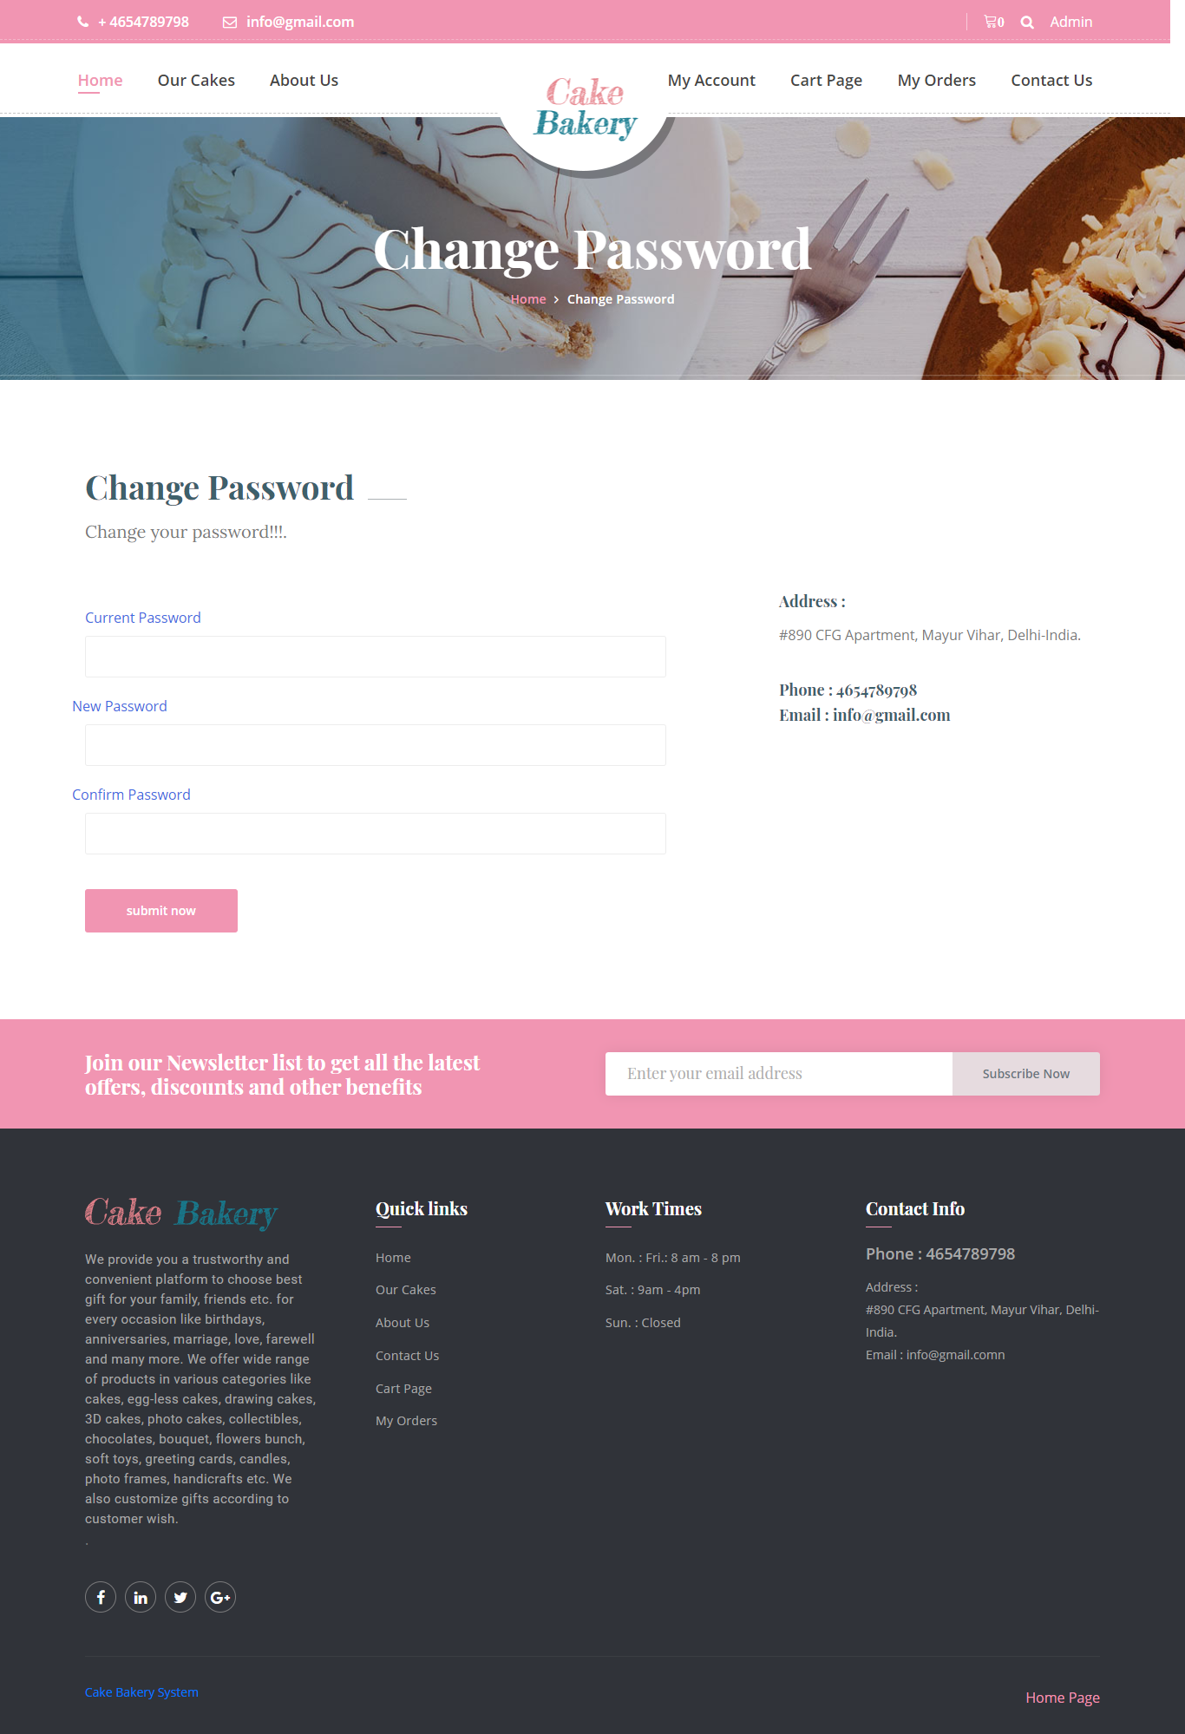

**Cart Page**

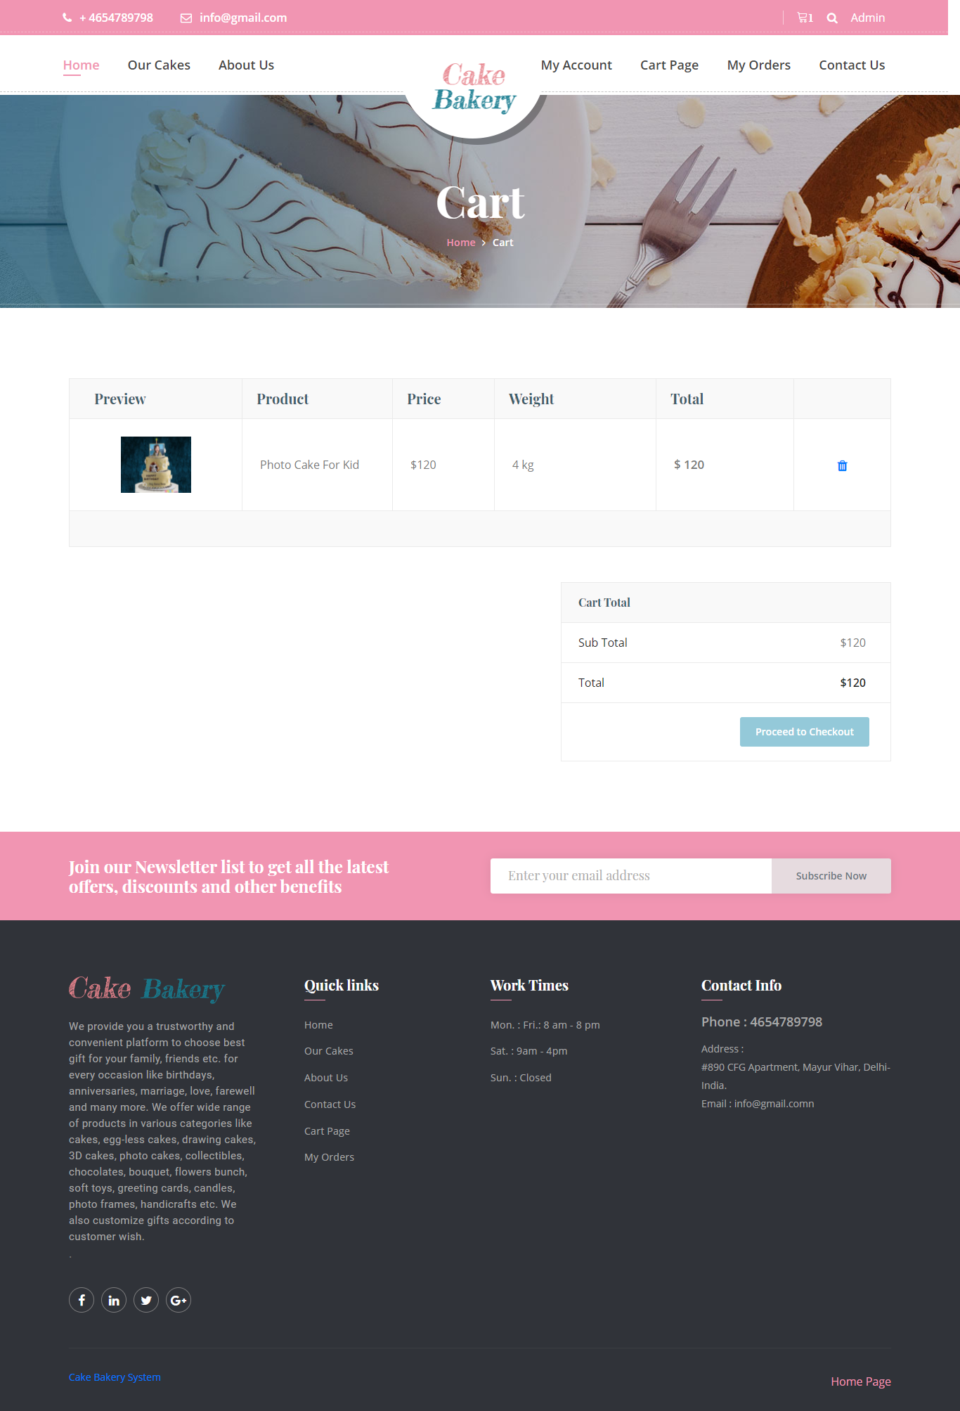

**Checkout Page**

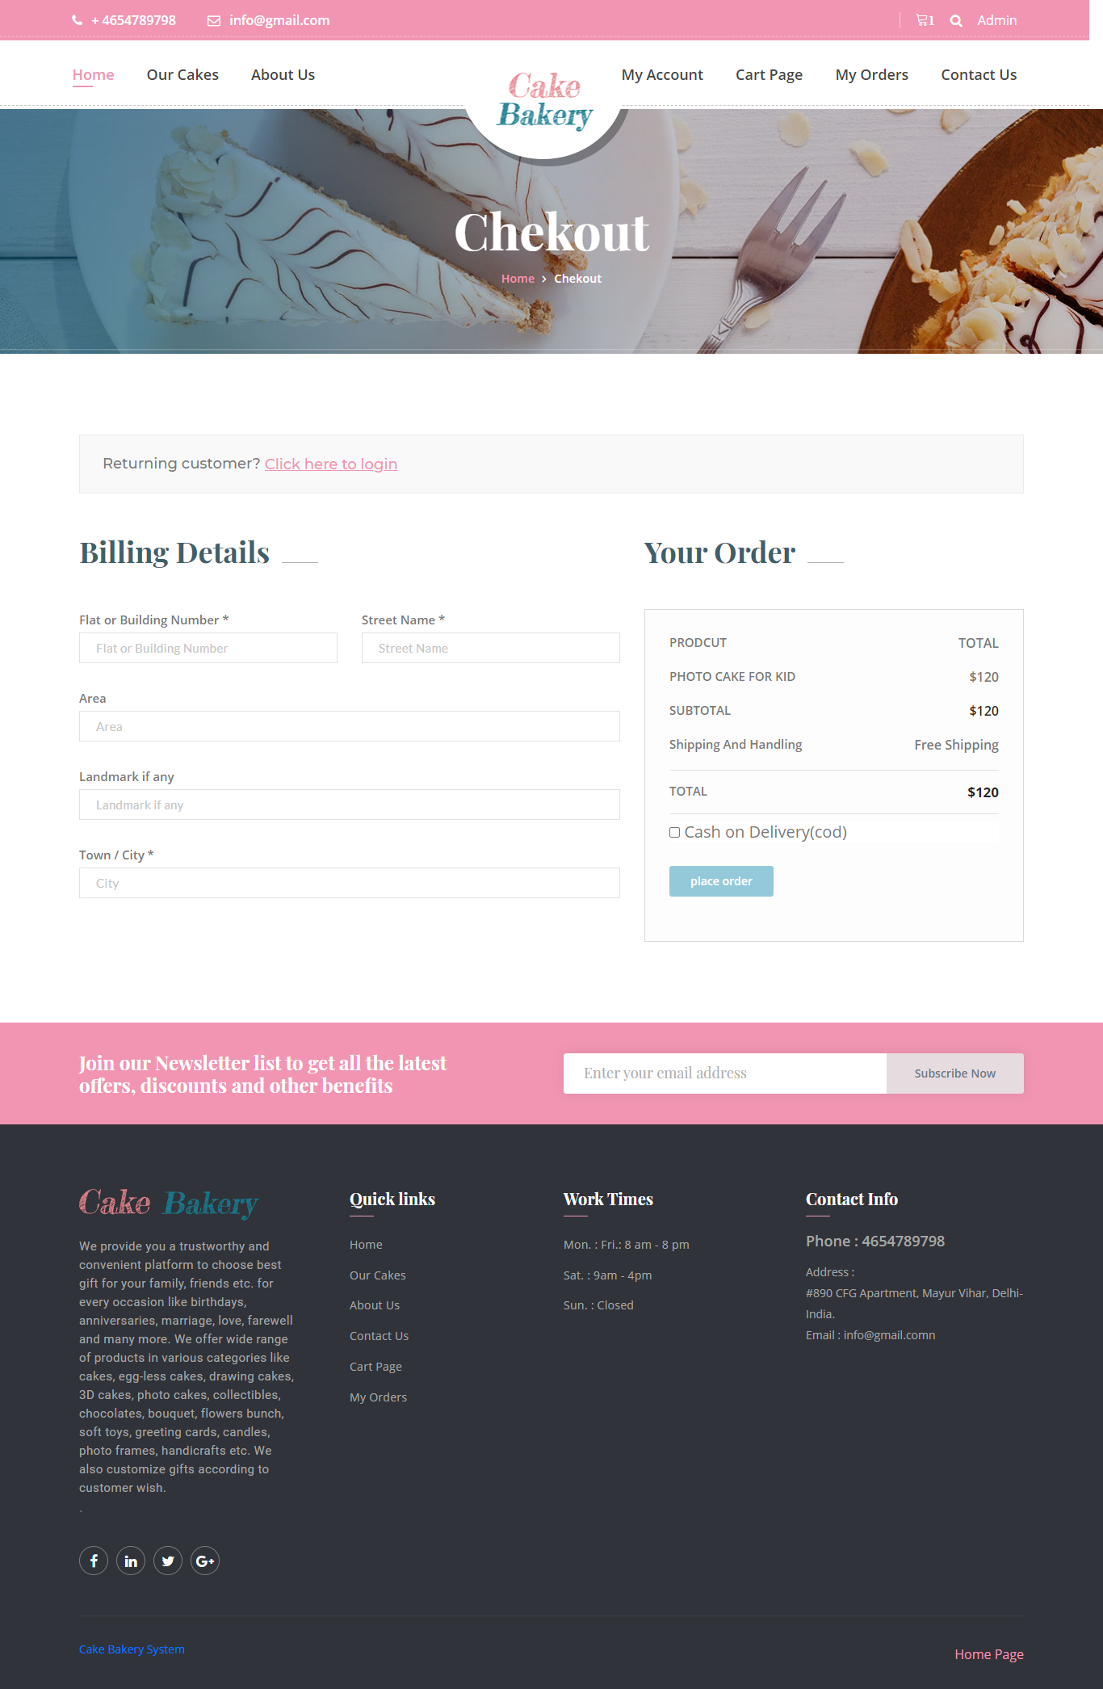

**My Order Page**

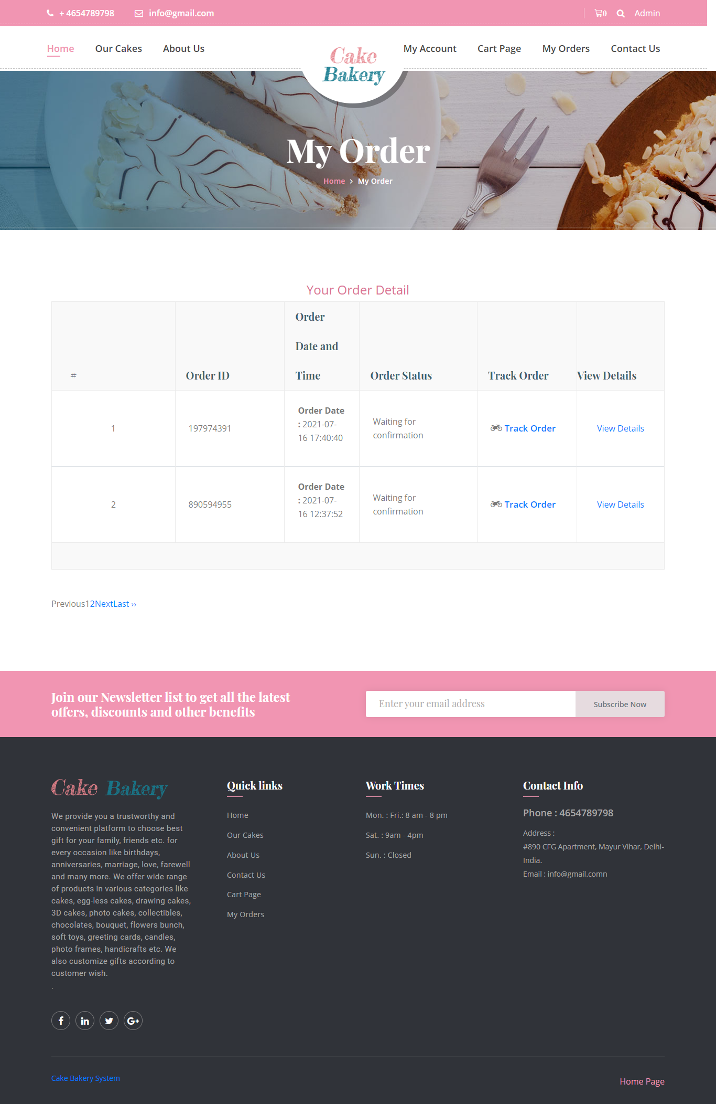

**Single Order Detail Page**

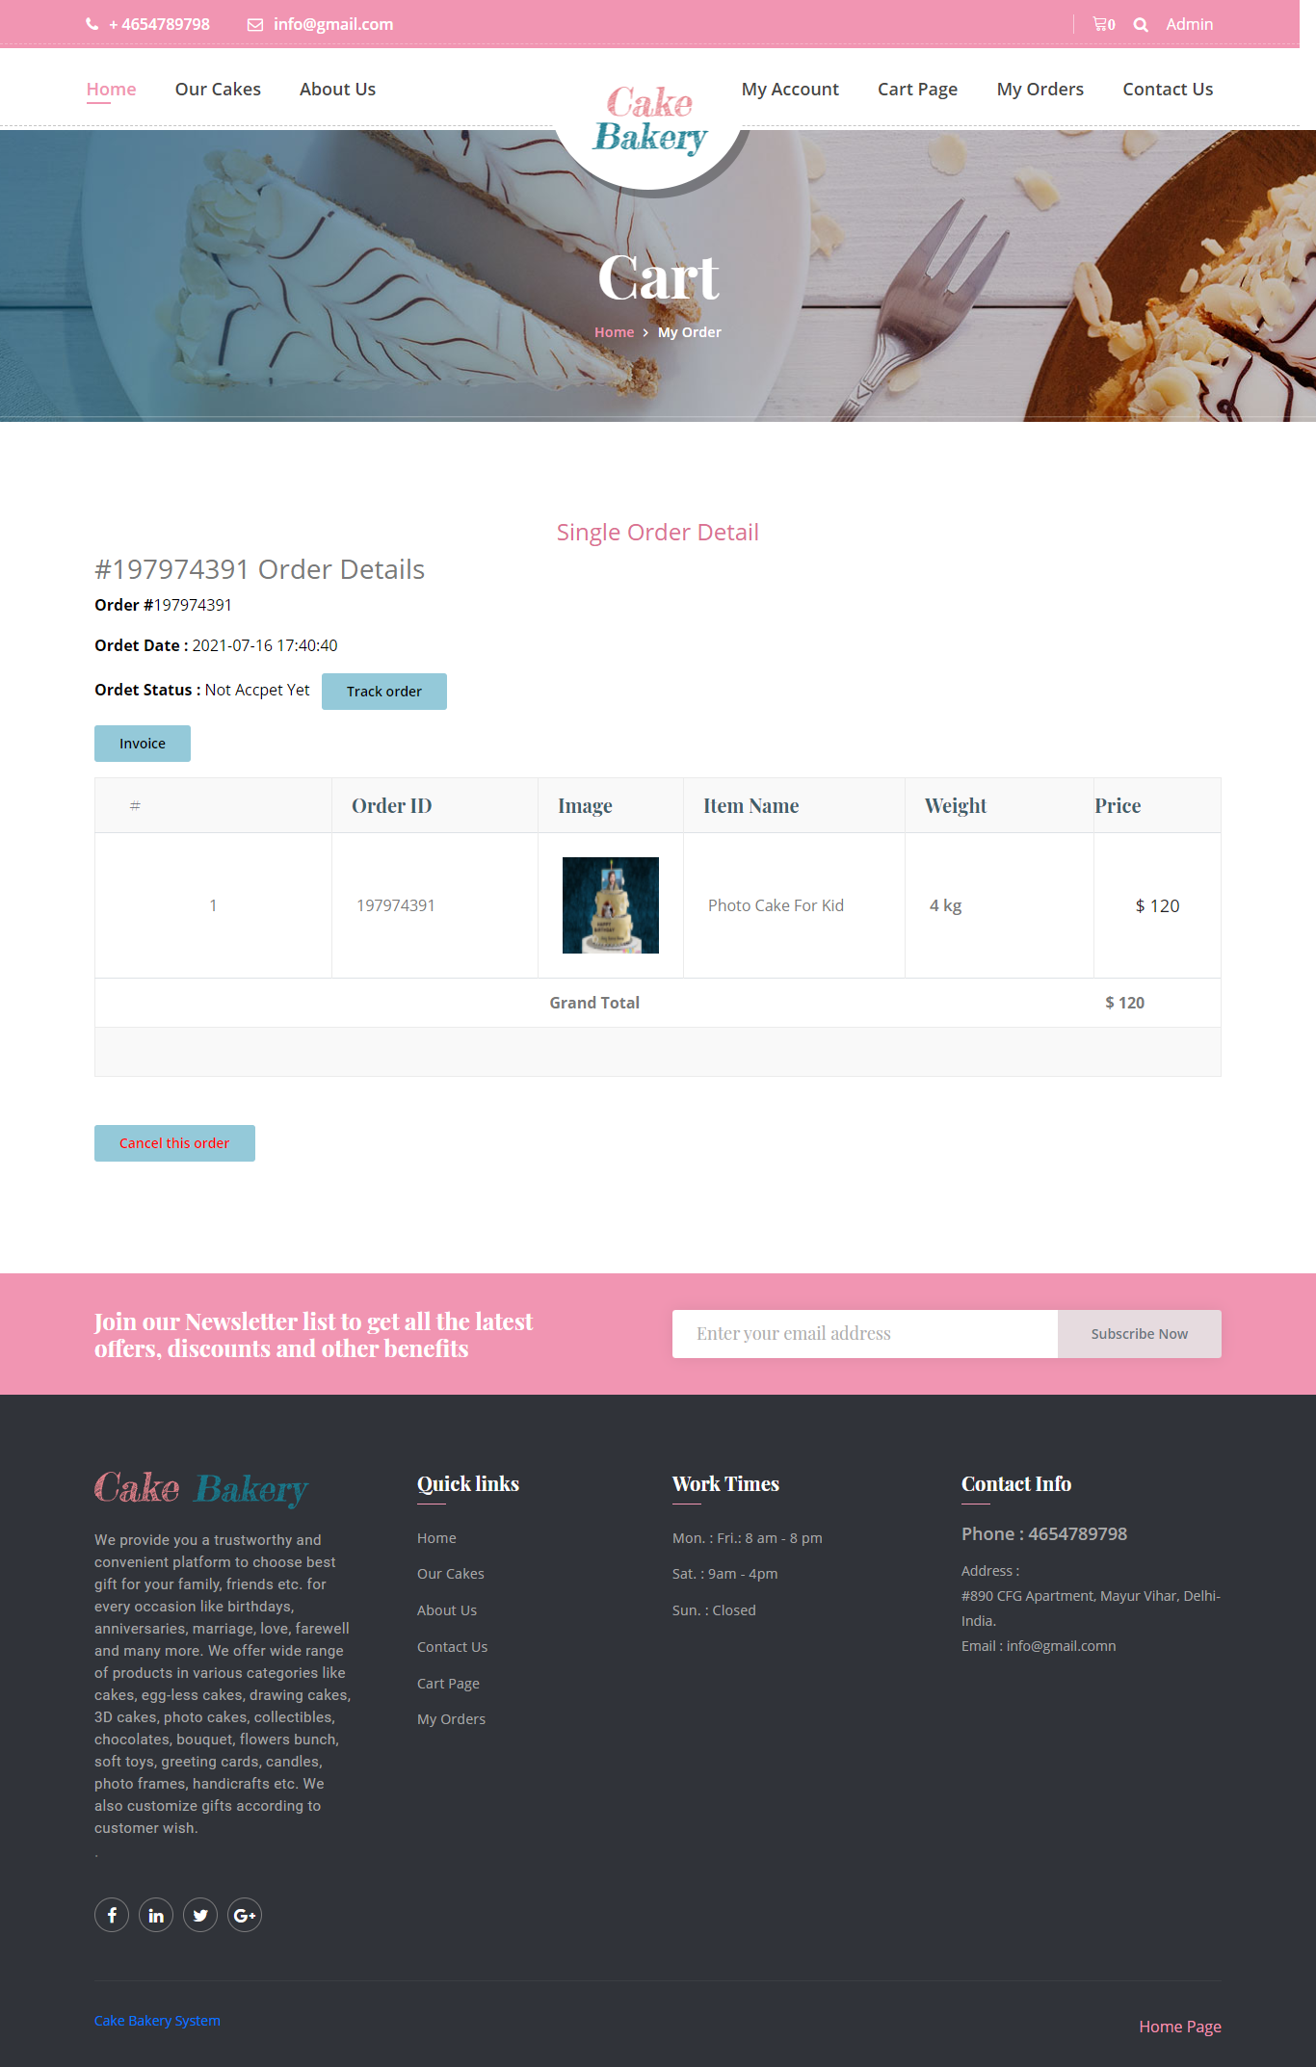

**Admin Panel**

**Login Page**

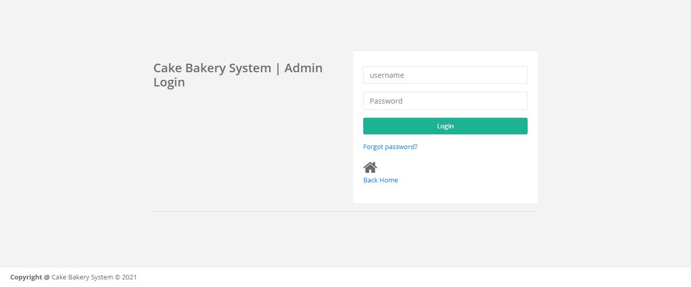

**Forgot Password**

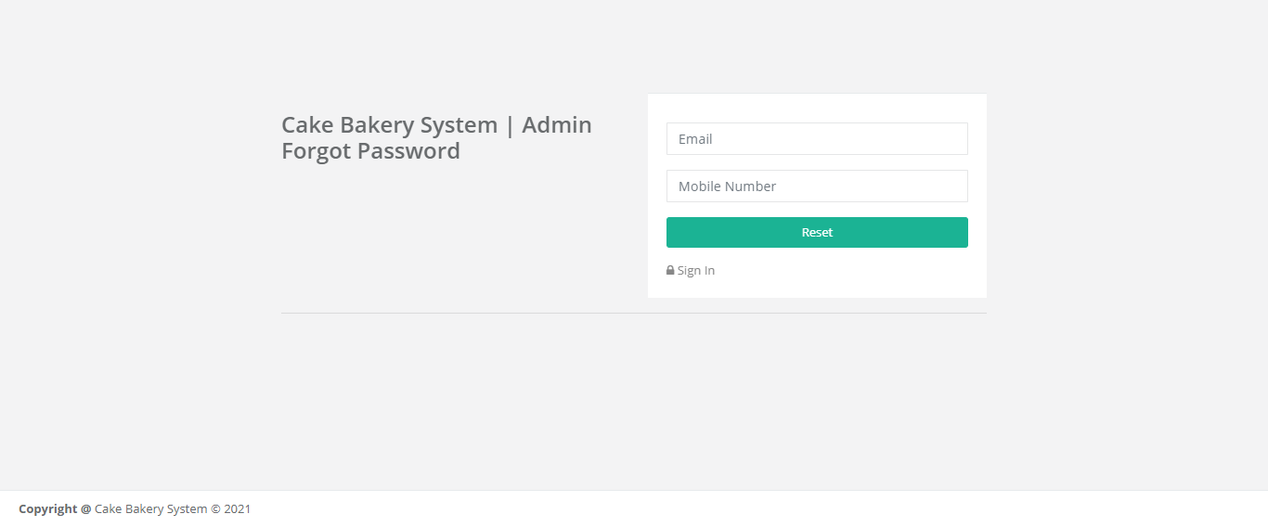

**Reset Password**

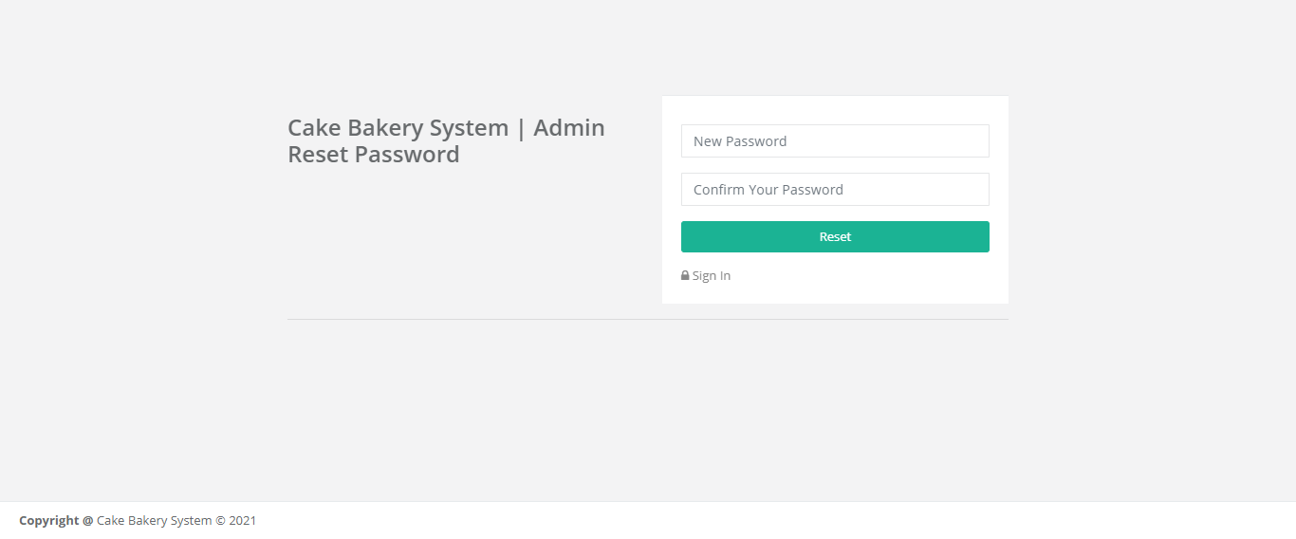

**Dashboard**

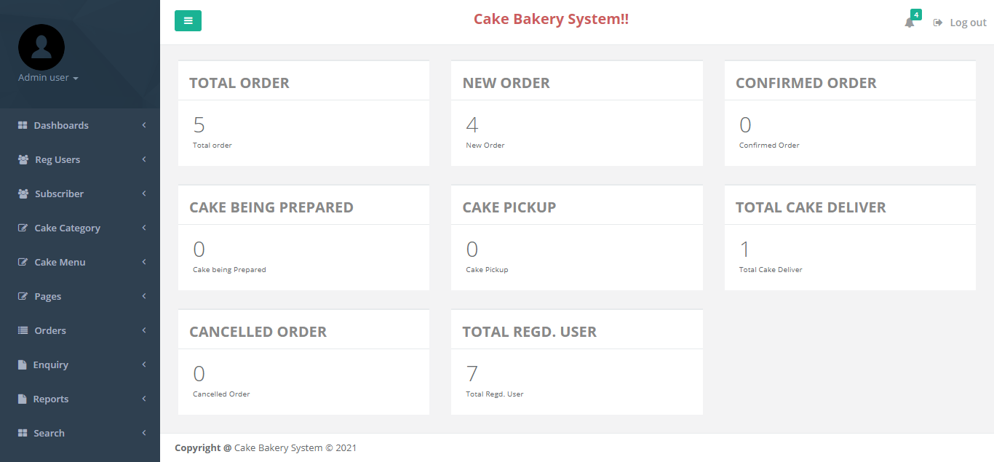

**Admin Profile**

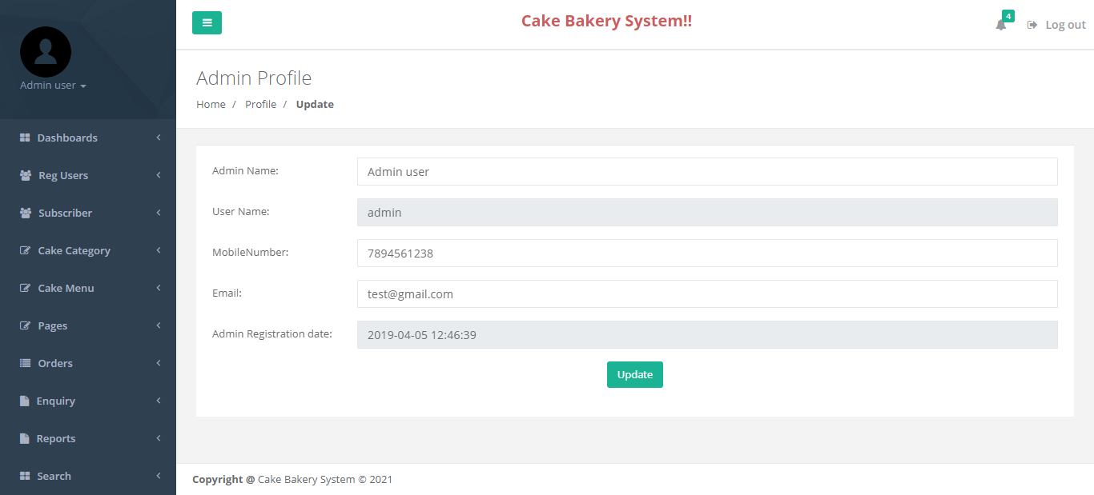

**Change Password**

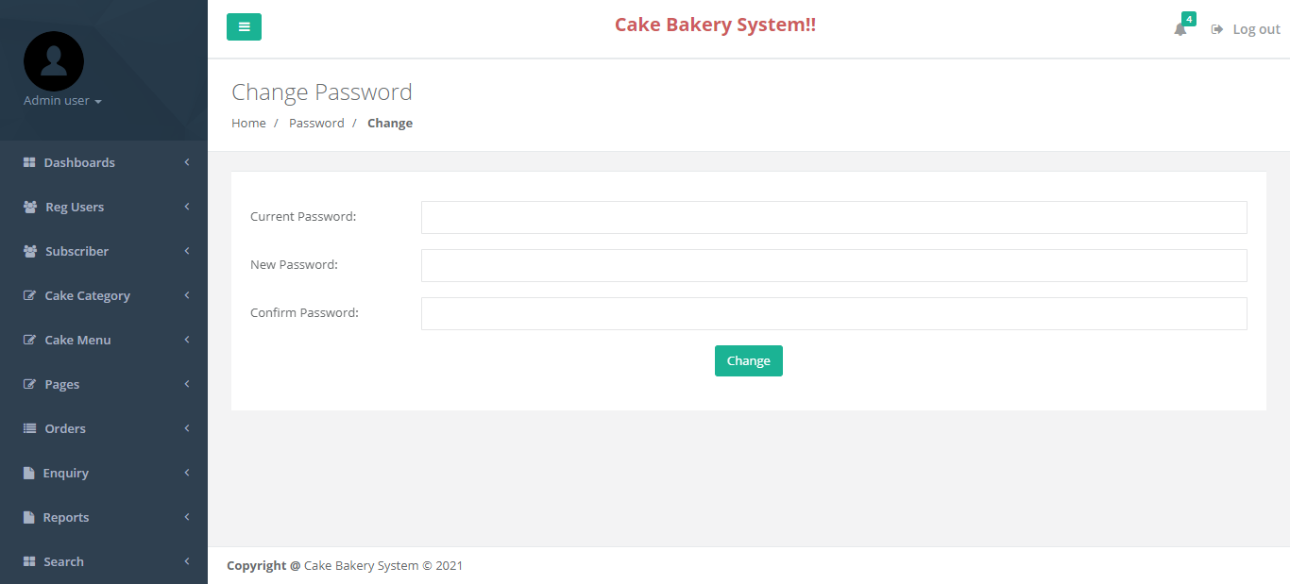

**Register Users**

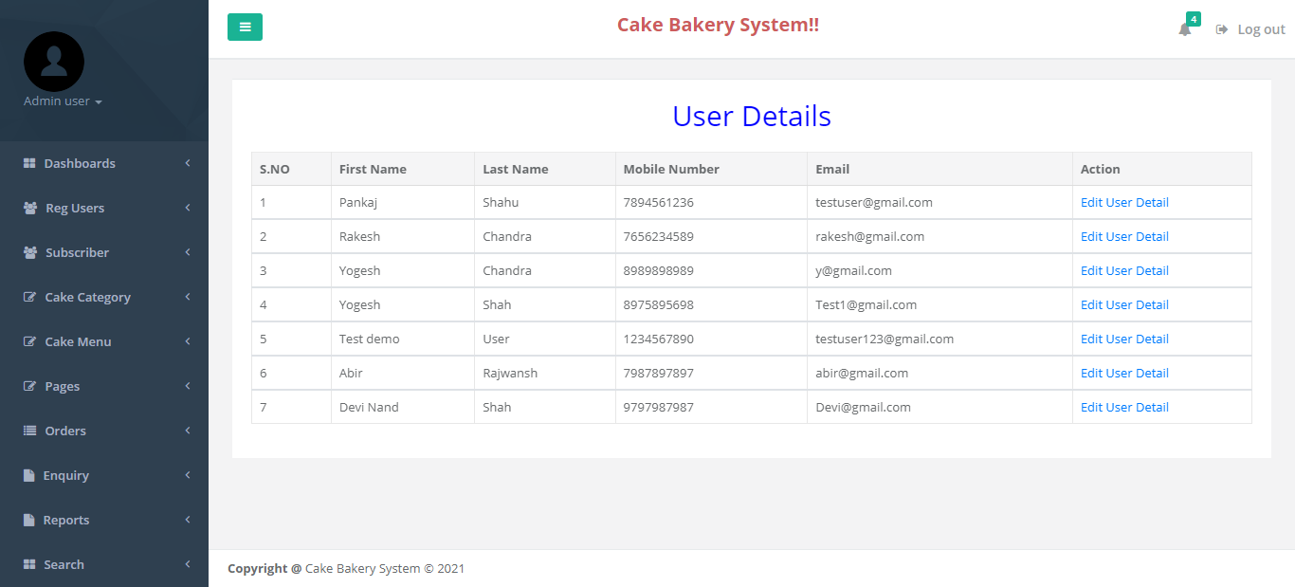

**User Details**

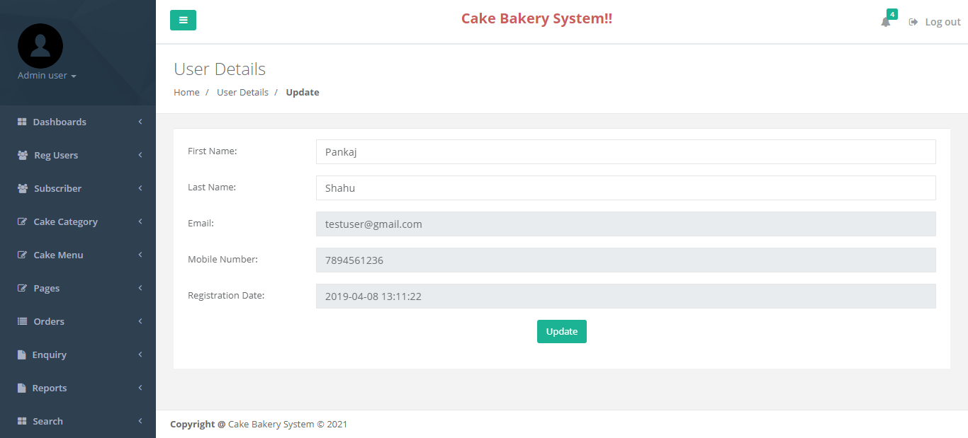

**Subscriber Mails**

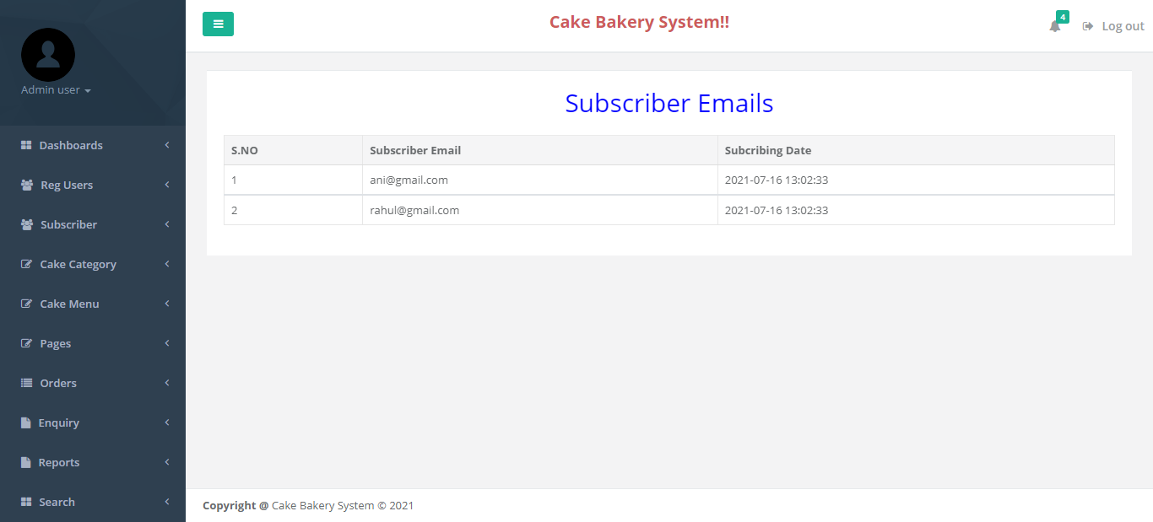

**Add Category**

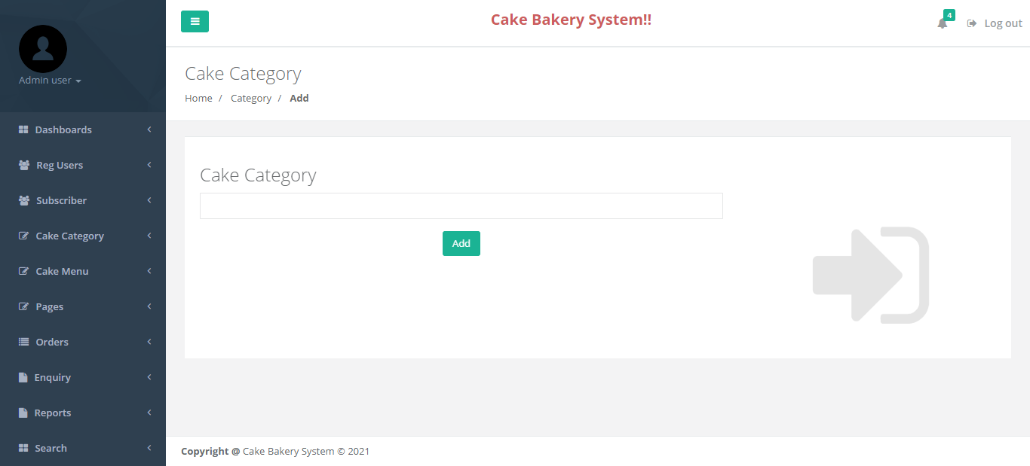

**Manage Cake Category**

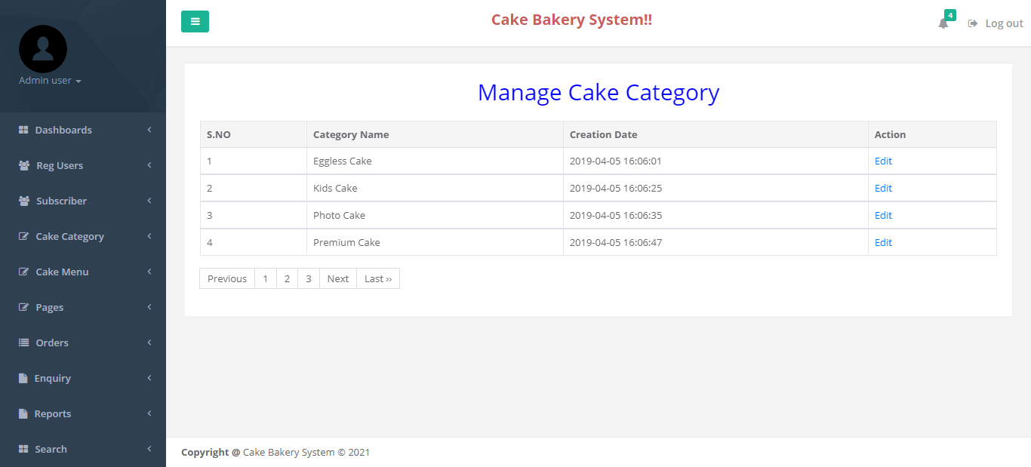

**Edit Category**

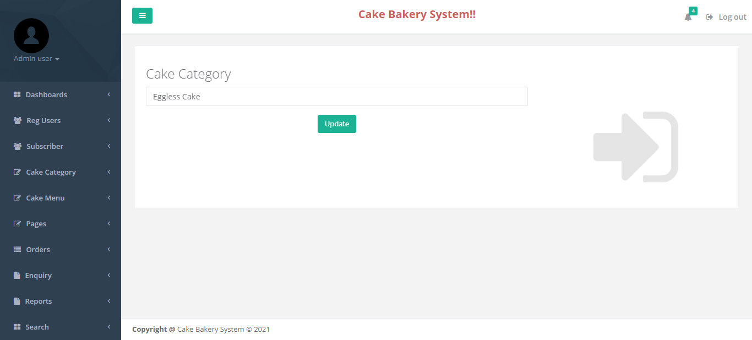

**Add Cake**

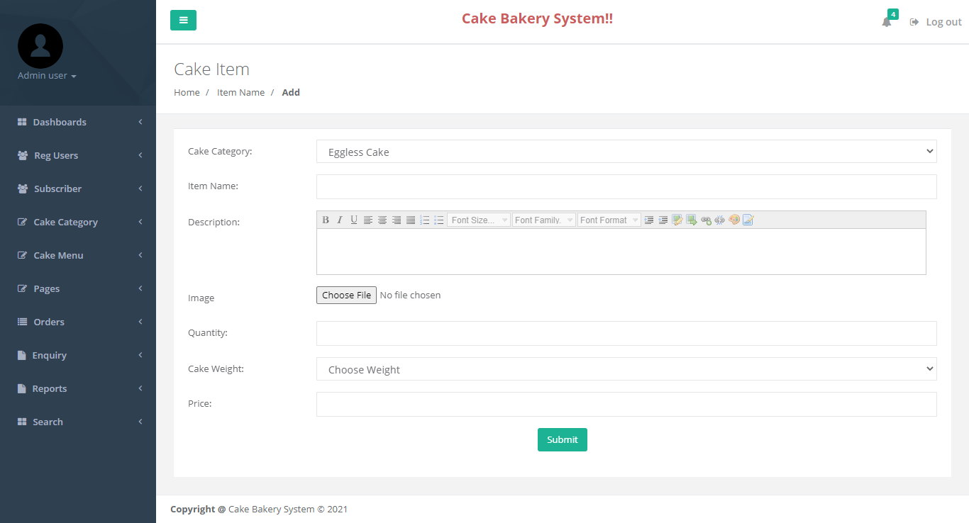

**Manage Cake**

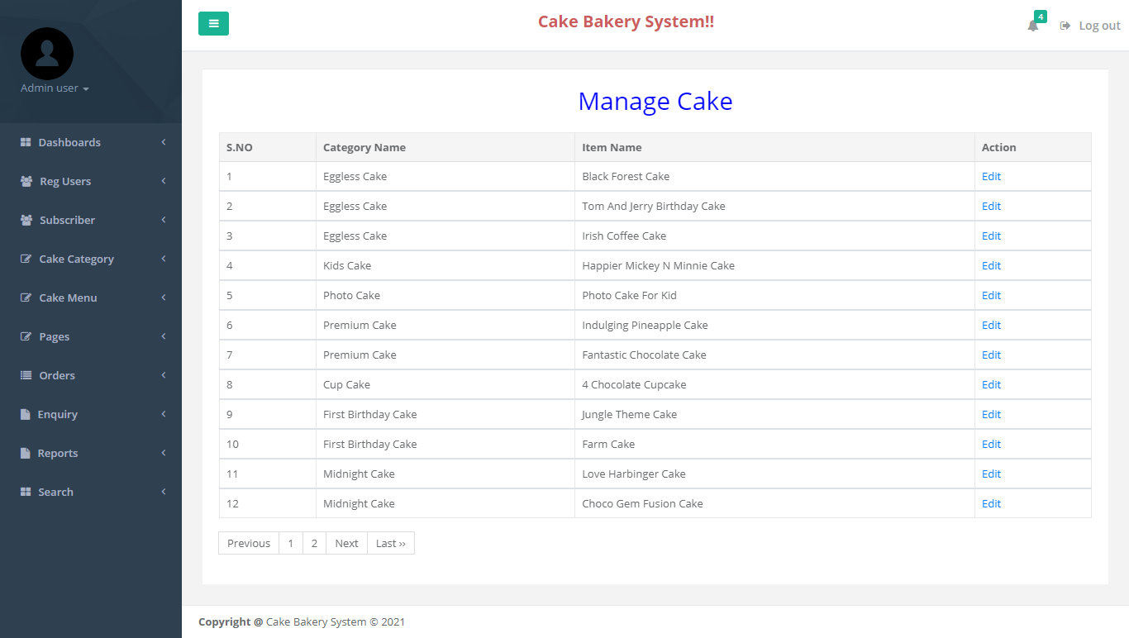

**Update Cake Detail**

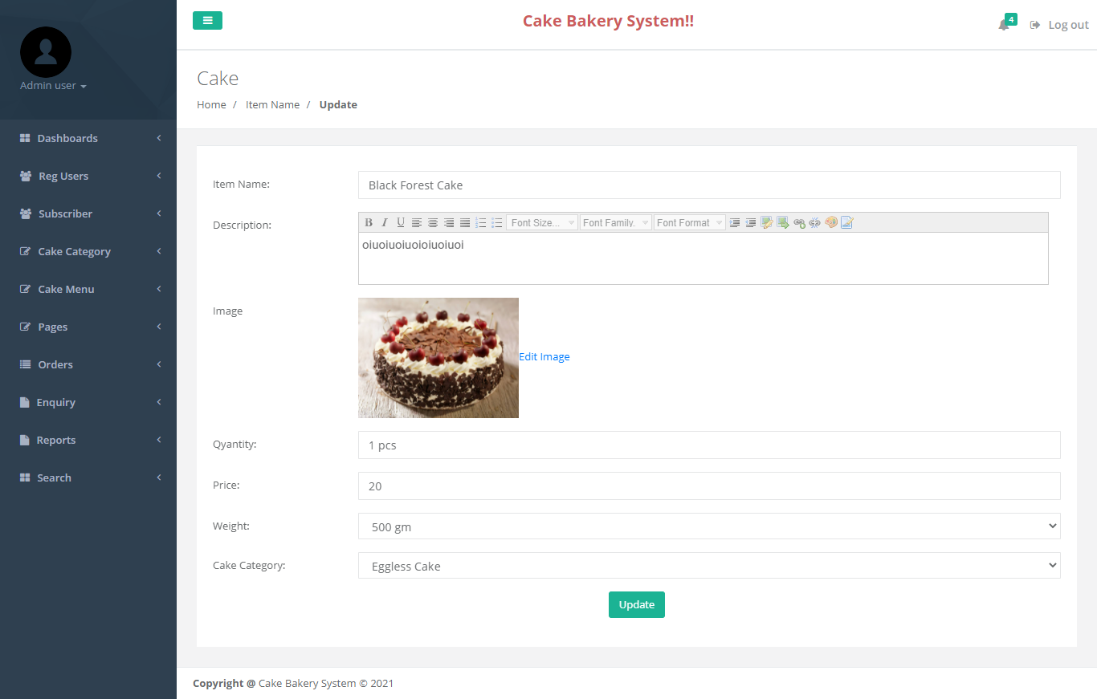

**About Us**

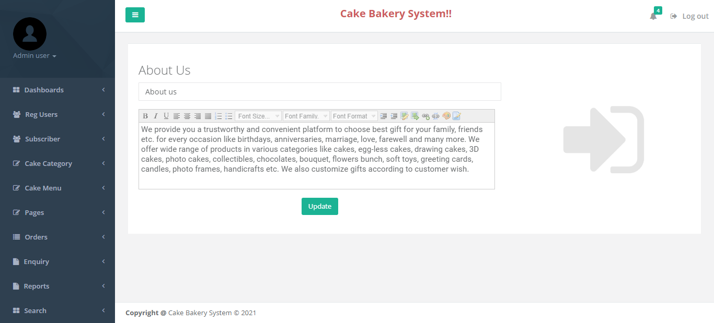

**Contact Us**

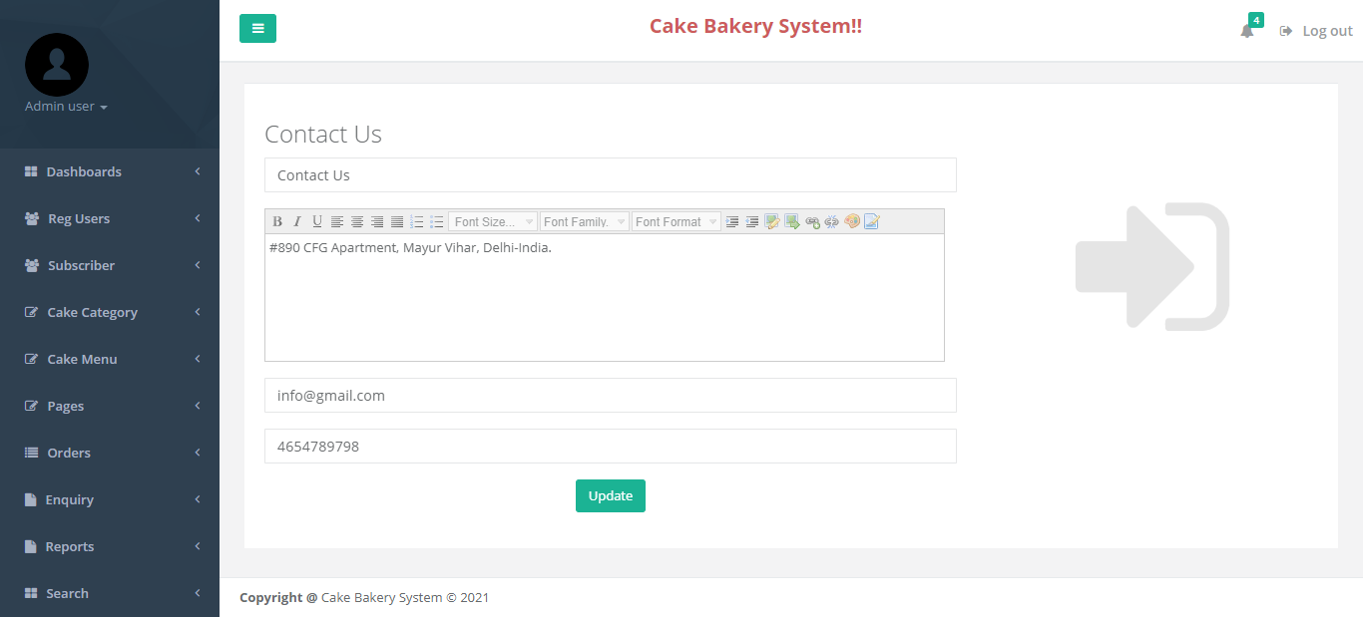

**Order Not Confirmed**

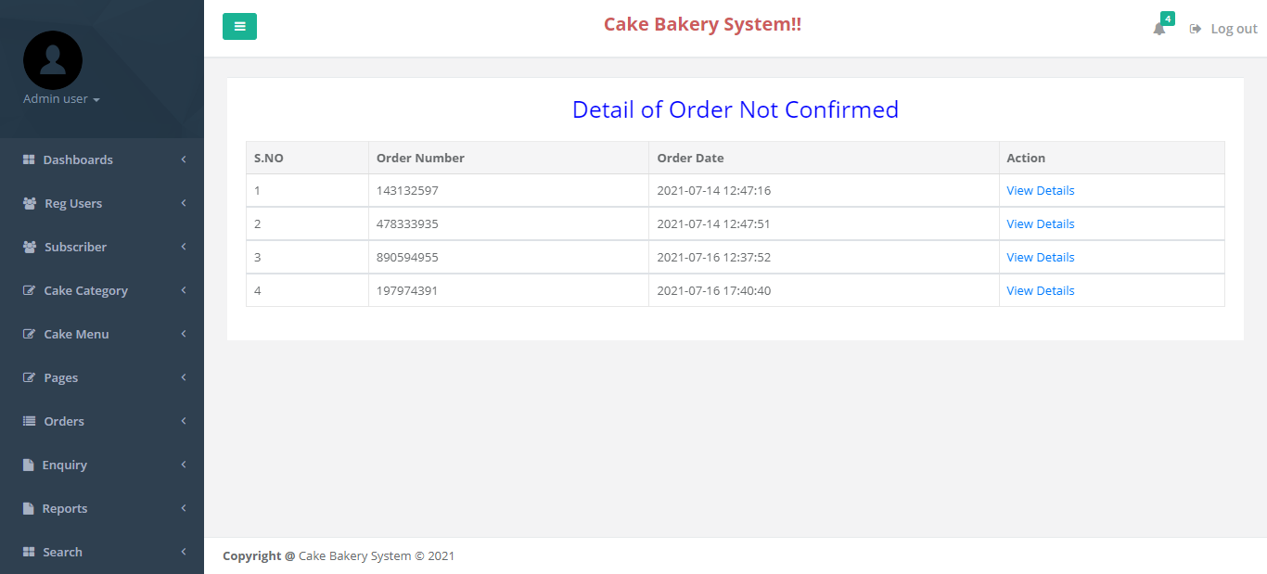

**Details of Order**

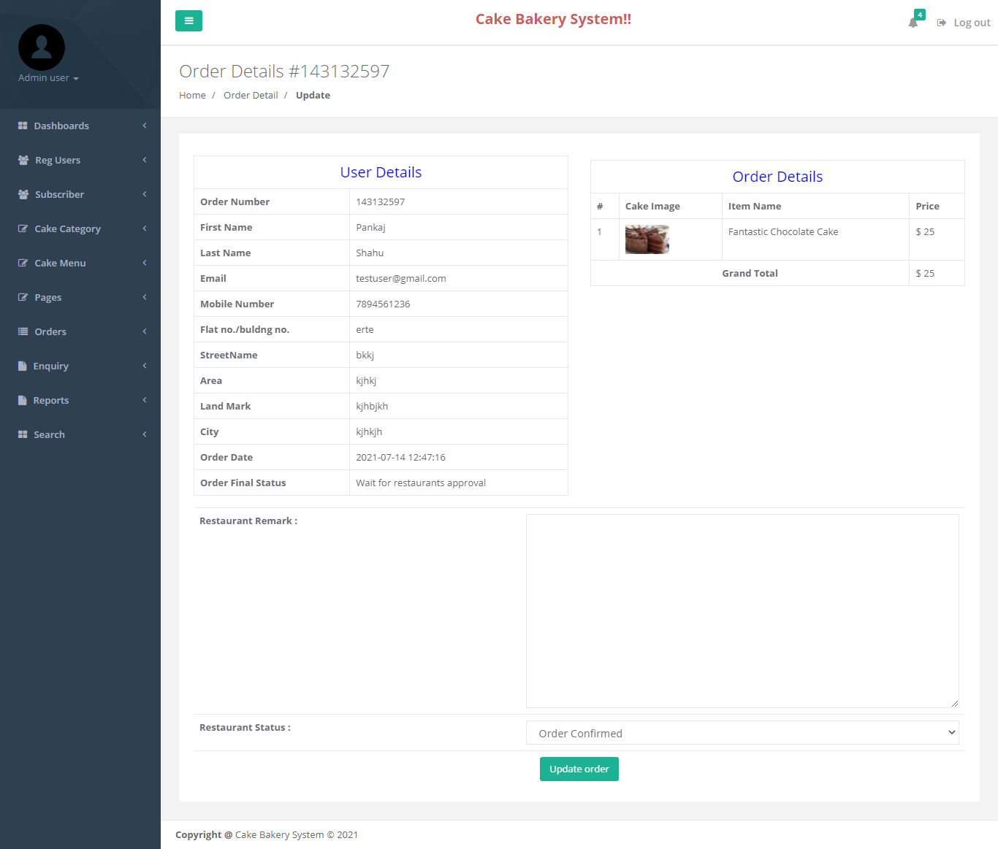

**Order Delivered**

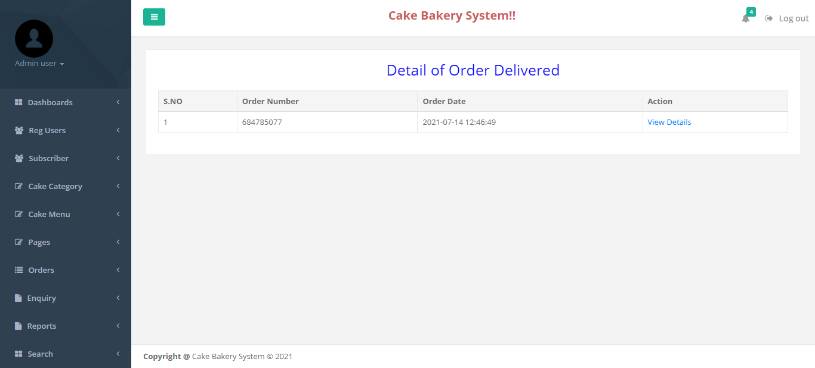

**Details of Order Delivered**

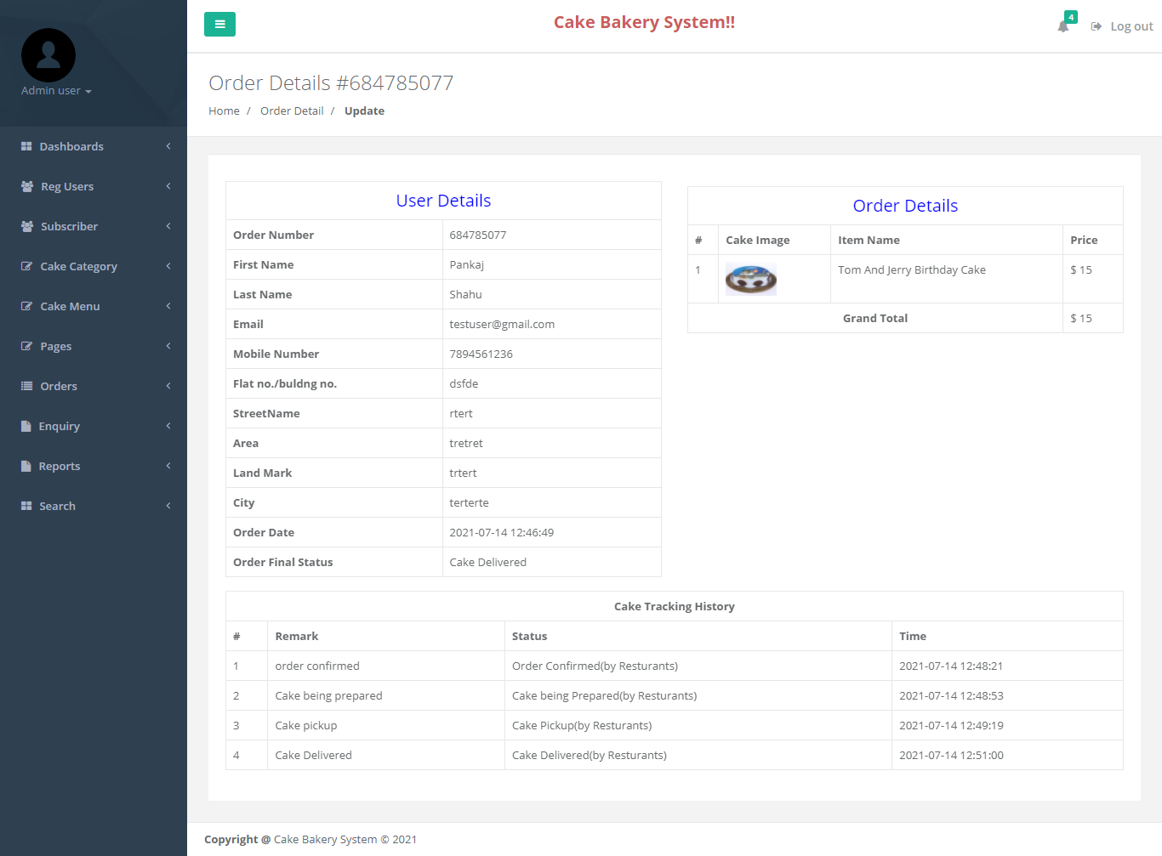

**Read Enquiry**

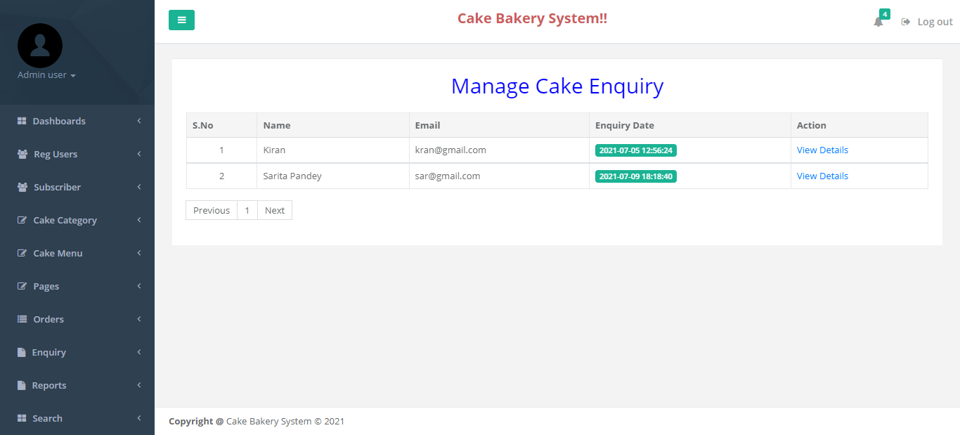

**View Enquiry Detail**

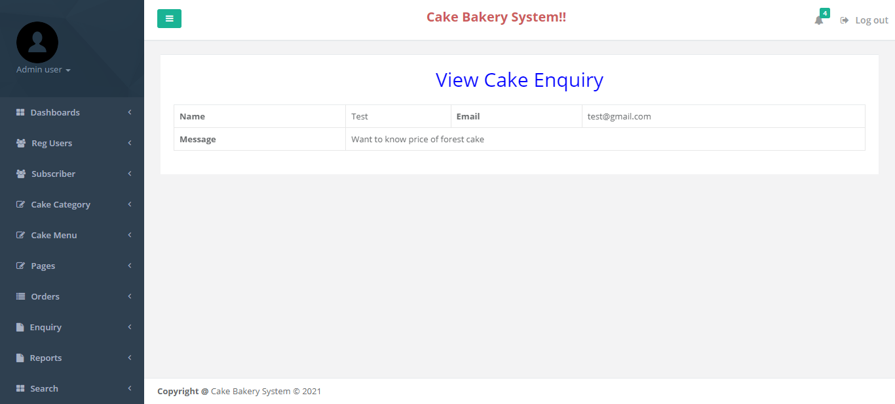

**Between Dates Report**

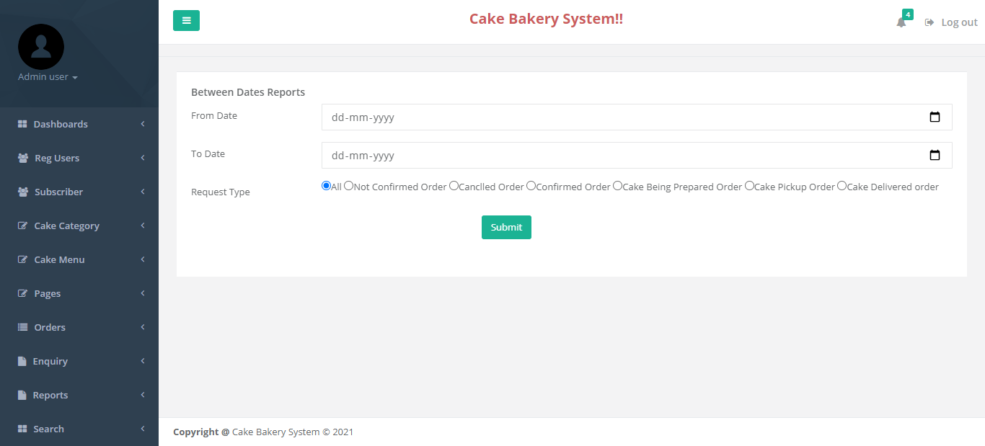

**All Orders**

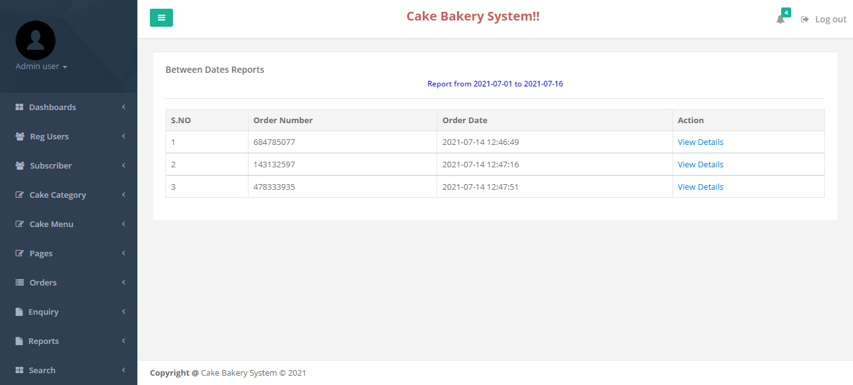

**Request Count Report**

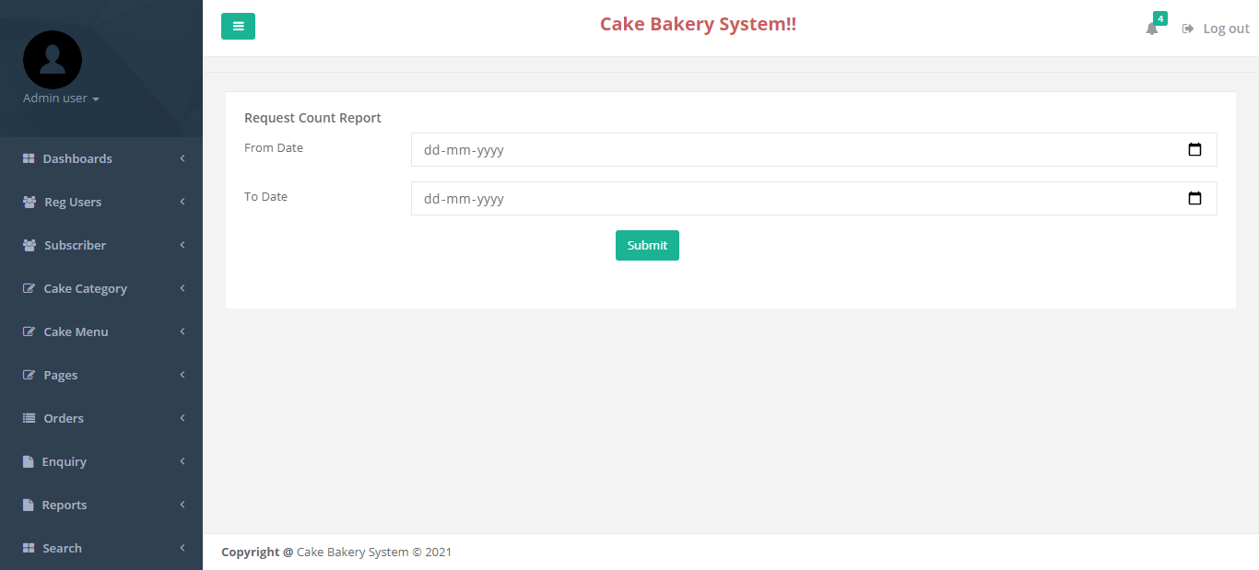

**Detail of Request Count Report**



**Detail of Request Count Report**

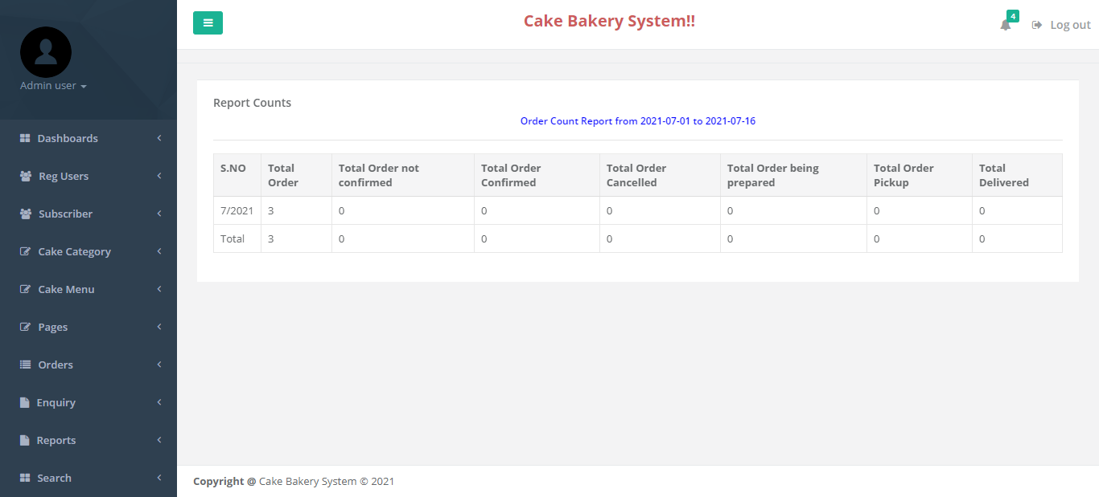

**Sales Report**

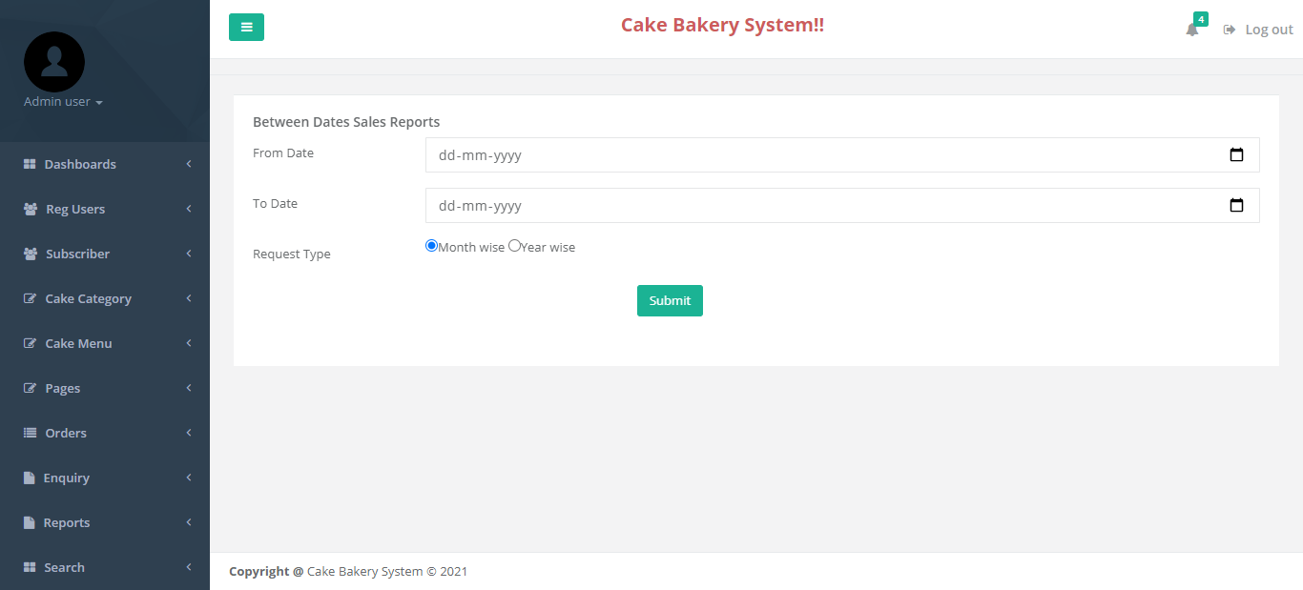

**Details Sales Report**

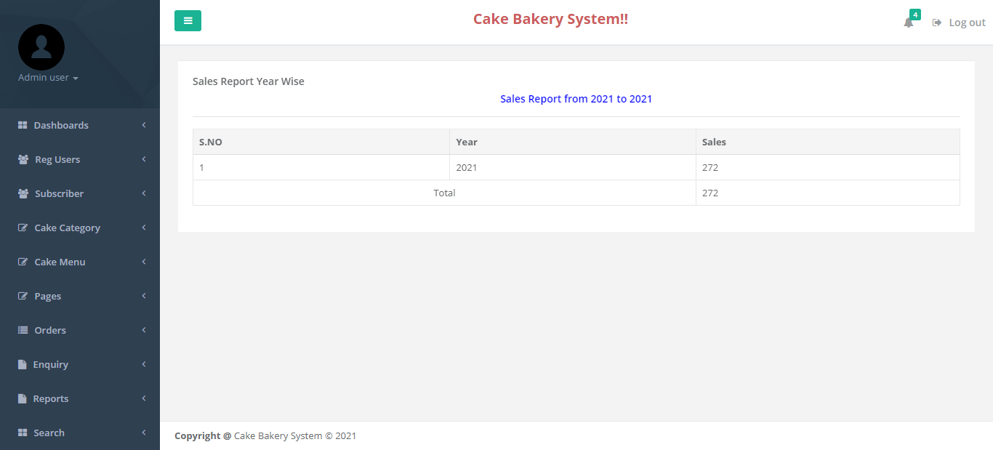

**Search Order**

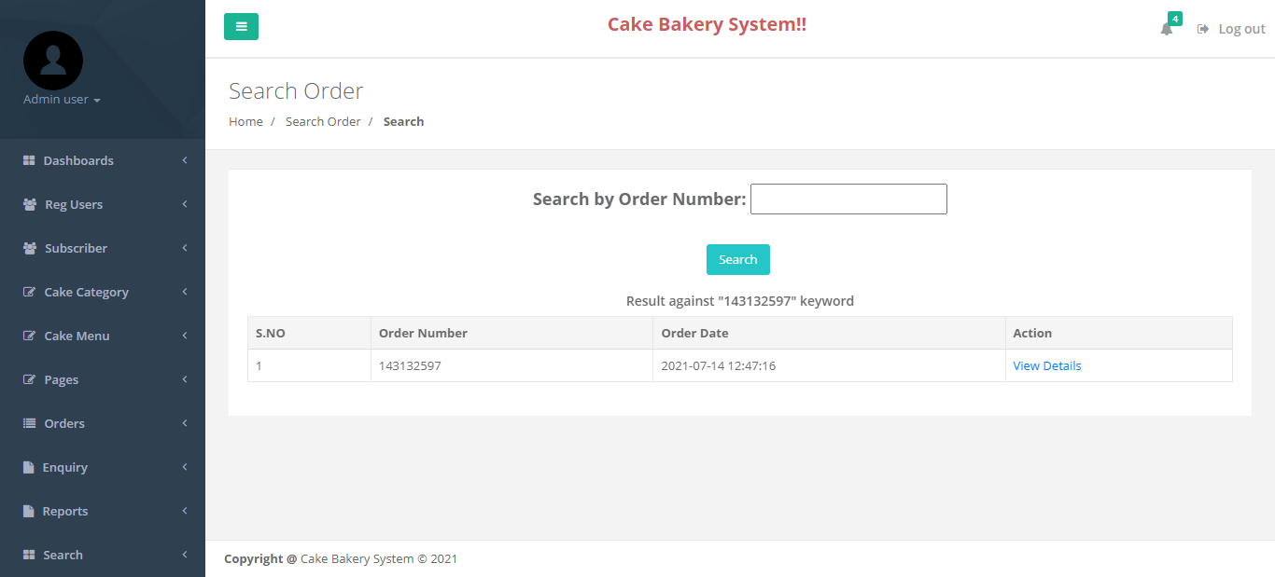

**CONCLUSION**

After a decade, the advancement and innovation of technology help people to manage their task easily and efficiently. In many other industry area have been used management system to assist their business grow long time ago, therefore it is also a trend that cause F&B industry to make use of a management system for their business. At the end of this project, the system can reduce and replace the human manpower task, reduce the time consume for each transaction and generate report for further management purpose by fully utilizing the system.

Obviously, the propose system can help improve the productivity of the restaurant and thus directly did an impact to the profitability of the restaurant. Furthermore, it can also help restaurant to reduce the cost of operation in term of manpower, because the system have already facilitate majority of the business process by using the system. Therefore, it is believed that the system can lead the restaurant’s business grow from time to time.

On the other hand, the technology nowadays allows the portability requirement easy to achieve. Therefore, portability has become one of the factor that have to take into consideration in the system development process. Because portability bring a lot of benefit to user while they using the system such as it provide convenience, accessibility, easy to communicate and etc. Hence, portability has done an impact to the social that everybody is much more preferable to complete their task with portable device.

In order to fulfill these all requirement, our proposed method is combined the cake Bakery system which is in mobile platform into the restaurant management system which is in computer platform. The integration of both features which develop a system that can let user to have an experience of portability which is user can process their cake Bakery through using their smart phone or tablet. Besides, restaurant manage their daily operation management through using the computer platform it is because computer have some other features such as it has a wider screen, other compatible system that can help to manage the restaurant and some other driver that needed to communicate with those necessary hardware.

**References**

**For PHP**

* <https://www.w3schools.com/php/default.asp>
* <https://www.sitepoint.com/php/>
* <https://www.php.net/>

**For MySQL**

* <https://www.mysql.com/>
* [http://www.mysqltutorial.org](http://www.mysqltutorial.org/)

**For XAMPP**

* <https://www.apachefriends.org/download.html>